A PROJECT REPORT

ON
CLASSIFICATION OF SLEEP DISORDERS APPLYING MACHINE
LEARNING ALGORITHMS AND USING SUPERVISED LEARNING

ALGORITHMS

Submitted for partial fulfillment of

Master of Computer Applications
2025 By
SAYAD SHAMEENA (4511-23-862-035)
Under the guidance of

Dr. D. SANDHYA RANI
Assistant Professor


Department of Computer Science and Informatics

UNIVERSITY COLLEGE OF ENGINEERING AND TECHNOLOGY,
MAHATMA GANDHI UNIVERSITY
YELLAREDDYGUDEM, NALGONDA - 508 254.

UNIVERSITY COLLEGE OF ENGINEERING AND TECHNOLOGY, MAHATMA GANDHI UNIVERSITY, YELLAREDDYGUDEM, NALGONDA.



DECLARATION BY THE CANDIDATE

This is SAYAD SHAMEENA, here by certify that the Project Report entitled
“CLASSIFICATION OF SLEEP DISORDERS APPLYING MACHINE
LEARNING ALGORITHMS AND USING SUPERVISED LEARNING
ALGORITHMS” is submitted in partial fulfillment of Masters of computer
Applications (IV SEM).
This is a record of bonafide work carried out by me under the guidance of Dr.D.SANDHYA RANI, Assistant Professor, University college of Engineering and Technology Mahatma Gandhi University, Nalgonda. The results embodied in this Project Report has not been reproduced or copied from any source. The results embodied in this project report have not been submitted to any other University or Institute for the Award of any other degree or diploma.

SAYAD SHAMEENA
(4511-23-862-035)

UNIVERSITY COLLEGE OF ENGINEERING AND TECHNOLOGY MAHATMA GANDHI UNIVERSITY
YELLAREDDYGUDEM, NALGONDA – 508 254.

COMPUTER SCIENCE & INFORMATICS DEPARTMENT

CERTIFICATE FROM PROJECT GUIDE

This is to certify that the project report entitled “CLASSIFICATION OF SLEEP
DISORDERS APPLYING MACHINE LEARNING ALGORITHMS AND USING SUPERVISED LEARNING ALGORITHMS” is submitted SAYAD
SHAMEENA partial fulfillment of Masters of computer Applications (IV SEM) is a Bonafide work carried by them during the academic year 2025.
The results of the investigations enclosed in this report have been verified and found satisfactory.

Dr. D. SANDHYA RANI
(Assistant Professor,
Department of CS&I)

UNIVERSITY COLLEGE OF ENGINEERING AND TECHNOLOGY MAHATMA GANDHI UNIVERSITY
YELLAREDDYGUDEM, NALGONDA – 508 254.

COMPUTER SCIENCE & INFORMATICS DEPARTMENT


CERTIFICATE FROM HOD

This is to certify that the project work entitled CLASSIFICATION OF SLEEP DISORDERS APPLYING MACHINE LEARNING ALGORITHMS AND USING
SUPERVISED LEARNING ALGORITHMS being submitted by SD.SHAMEENA to
University College of Engineering and Technology MGU, in partial fulfillment of the of
Masters of Computer Applications(IV SEM), is a record of bonafide work carried by them.

Head of the Department,
External Examiner Department of CS& I

ACKNOWLEDGEMENT

I express my sincere thanks to Dr. M JAYANTHI, Head of the Dept. of MCA, for giving me opportunity to do project, without her blessings it would not have been possible for me to carry put this treatise work.

I express my deep sense of gratitude to Dr. D. SANDHYA RANI, Department of Computer Science and Informatics Internal guide for her help through provoking discussions, invigorating suggestions extended to me with immense care, zeal throughout my work.

Finally, it is our pleasure to thank all the faculty members of department for their cooperation in completes this project.

SAYAD SHAMEENA
(4511-23-862-035)

CLASSIFICATION OF SLEEP DISORDERS
APPLYING MACHINE LEARNING ALGORITHMS
AND USING SUPERVISED LEARNING ALGORITHMS

Classification of Sleep Disorders applying Machine Learning algorithms and using
Supervised Learning algorithms

ABSTRACT

Sleep disorder classification is crucial in improving human quality of life. Sleep disorders and apnoea can have a significant influence on human health. Sleep-stage classification by experts in the field is an arduous task and is prone to human error. The development of accurate machine learning algorithms (MLAs) for sleep disorder classification requires analysing, monitoring and diagnosing sleep disorders. This paper compares deep learning algorithms and conventional MLAs to classify sleep disorders. This study proposes an optimised method for the Classification of Sleep Disorders and uses the Sleep Health and Lifestyle Dataset publicly available online to evaluate the proposed model. The optimisations were conducted using a genetic algorithm to tune the parameters of different machine learning algorithms. An evaluation and comparison of the proposed algorithm against stateof-the-art machine learning algorithms to classify sleep disorders. The dataset includes 400 rows and 13 columns with various features representing sleep and daily activities. The knearest neighbours, support vector machine, decision tree, random forest deep learning algorithms were assessed. The experimental results reveal significant performance differences between the evaluated algorithms. The proposed algorithms obtained a classification accuracy of 83.19%, 92.04%, 88.50% and ,91.15% , respectively.

TABLE OF CONTENTS

Page No.

Abstract…………………………………………………………………………………......VII

Table of contents…………………………………………………………………………....VIII

List of figures………………………………………………………………………………..XI

CHAPTER 1: INTRODUCTION

1.1 Objective…………………………………………………………………………….1

1.2 Scope………………………………………………………………………………...2

1.3 Overview…………………………………………………………………………….3

CHAPTER 2: LITERATURE SURVEY

2.1 Basic Concept………………………………………………………………………..5

CHAPTER 3: SYSTEM ANALYSIS

3.1 Existing System…………………………………………………………………..….10

3.1.1 Disadvantages of Existing System………………………………………....11

3.2 Problem Statements………………………………………………………………….11

3.2.1 The System Model………………………………………………………….12

3.2.2 System Assumption…………………………………………………………13

3.3 Proposed System……………………………………………………………………13

3.3.1 Advantages of Proposed System……………………………………………14

CHAPTER 4: SYSTEM DESIGN

4.1 Introduction…………………………………………………………………………15

4.1.1 Data flow Diagram……………………………………………………….....15

4.1.2 Use case Diagram……………………………………………………….…16

4.1.3 Class Diagram……………………………………………………………..17

4.1.4 Sequence Diagram………………………………………………………...18

4.1.5 Activity Diagram……………………………………………………...…..19
4.1.6 Component Diagram………………………………………………………20

4.2 Modules
4.2.1 Data Collection………………………………………………………………22
4.2.2 Data Loading/Modules…………………………………………………….…22
4.2.3 Analysis………………………………………………………………………23
4.2.4 Preprocessing/Data Manipulation……………………………………………23
4.2.5 Train-Test-split……………………………………………………………….23
4.2.6 Model Building Algorithms………………………………………………….24
4.2.7 Prediction………………………………………………………………….…24
4.2.8 Result………………………………………………………………………...25

CHAPTER 5: ALGORITHM…………………………………………………………...26

CHAPTER 6: SYSTEM REQUIREMENT SPECIFICATION……………………....28

6.1 Functional Requirements………………………………………………………..28

6.1.1 Input Design………………………………………………………….......28

6.1.2 Output Design…………………………………………….……………....29

6.2 Performance Requirements………………………………………………….…...29

6.3 Software Requirement…………….……………………...……………………....30

6.4 Hardware Requirement……………………………………………………….…..30

CHAPTER 7: SYSTEM STUDY

7.1 Feasibility Study………………………….…………………………….…….…..31

7.1.1 Economical Feasibility……………………………….……………….....31

7.1.2 Technical Feasibility………………..………………………………..…..32

7.1.3 Social Feasibility……………………………………………….…….…..32

CHAPTER 8: SCREEN SHOTS………………………………………………….……..33

CHAPTER 9: SAMPLE CODE…………………………………………………….…...43

CHAPTER 10: SYSTEM TESTING

10.1 Testing……………………………………………………………………….46

10.1.1 Unit Testing…………………….…………………………………....….46

10.1.2 Integration Testing…………………….…………………………….…..47

10.1.3 Acceptance Testing………….……………………………………….….47

CHAPTER 11: CONCLUSION…………………………………………………….…..49

CHAPTER 12: BIBILOGRAPHY……………………………………………….……..50

LIST OF FIGURES

Page No.

3.2.1 The System Model…………………………………………………………………12

4.1.1 Data flow Diagram………………………………………………………………....15

4.1.2 Use case Diagram…………………………………………………………………..16

4.1.3 Class Diagram………………………………………………………………………17

4.1.4 Sequence Diagram………………………………………………………………….18

4.1.5 Activity Diagram……………………………………….…………………………..19

4.1.6 Component Diagram………………………………………………………………..20

CHAPTER 1
INTRODUCTION

1.1 Objective
The primary objective of this project is to develop an intelligent and automated system capable of predicting sleep disorders using various machine learning (ML) and deep learning (DL) techniques. In recent years, the significance of sleep on overall health and well-being has been increasingly recognized. Sleep disorders such as Insomnia and Sleep Apnea have been associated with serious health problems including cardiovascular disease, obesity, diabetes, and mental health disorders such as depression and anxiety. The traditional method of diagnosing sleep disorders involves Polysomnography (PSG), which is resource-intensive, requires a clinical setting, and is expensive.
The development of an ML/DL-based diagnostic model aims to reduce these limitations by providing an alternative that can analyze patient data and predict potential sleep disorders efficiently. This system is designed to process user data (in the form of structured CSV files) and classify the sleep condition into three distinct categories: None (No disorder), Insomnia, and Sleep Apnea.
The specific objectives of this project are:
- To design and build a model using ML/DL algorithms such as Support Vector Machine (SVM), K-Nearest Neighbour (KNN), Decision Tree (DT), Random Forest (RF), and Artificial Neural Network (ANN) to classify sleep disorders.
- To train and evaluate these models using a real-world dataset (Sleep Health and Lifestyle Dataset) with various features such as age, gender, BMI, sleep duration, and lifestyle factors like smoking and alcohol consumption.
- To identify the best-performing algorithm based on performance metrics like Accuracy, Precision, Recall, and F1-Score.
- To deploy the best model (ANN, based on achieved accuracy) through a web interface (using Streamlit), allowing users to predict sleep disorders from uploaded CSV files.
- To make the system accessible, reliable, and scalable, enabling its integration into clinical workflows or public health screening initiatives.
- To demonstrate the role of Genetic Algorithms for hyperparameter optimization, further improving model performance.

1.2 Scope
The scope of this project encompasses the use of supervised ML and DL algorithms to classify individuals based on their likelihood of suffering from sleep disorders. The predictions are based on a variety of factors collected from individuals, including demographic data, lifestyle habits, and self-reported health conditions.
The system processes the following key features from the dataset:
- Age & Gender: Demographic factors that influence sleep quality.
- BMI Category: Overweight or obese individuals are at higher risk for sleep apnea.
- Sleep Duration & Quality: Direct indicators of sleep health.
- Physical Activity Level: Impacts both sleep quality and metabolic health.
- Smoking Status & Alcohol Consumption: Lifestyle factors known to disturb sleep cycles.
- Caffeine Consumption: Can negatively affect sleep if consumed in excess.
- Occupation: Certain professions, especially those involving shift work, are more prone to sleep disturbances.
- Blood Pressure: High BP is often associated with sleep apnea.
Within this scope, the project will:
- Handle missing values and perform data preprocessing.
- Split the dataset into training and test sets.
- Apply ML algorithms such as SVM, KNN, DT, RF, and ANN.
- Perform evaluation using standard metrics.
- Identify ANN as the best performing model.
- Deploy the ANN model using Streamlit as a web application for practical usage.

Additionally:
- The system is designed to be scalable, user-friendly, and requires minimal technical expertise from the end-user.
- The dataset is limited to the features provided, hence no external medical data (like EEG signals) are used.
- The application is intended for academic, research, and preliminary clinical purposes only, not as a substitute for professional diagnosis.

1.3 Overview
Sleep disorders have been increasing in prevalence across populations globally, making it imperative to develop reliable diagnostic tools that are accessible to both healthcare providers and the general public. The manual process of identifying sleep disorders is not only timeconsuming but also costly. Therefore, the introduction of Artificial Intelligence (AI) into this field holds great promise for both efficiency and scalability.
In this project:
- A publicly available dataset from Kaggle ("Sleep Health and Lifestyle Dataset") has been used. This dataset contains 400 records and 13 variables relevant to sleep health.
- The dataset includes individuals' demographic and lifestyle details, as well as their sleep disorder status classified into None, Insomnia, or Sleep Apnea.
- Preprocessing steps include handling missing values, encoding categorical features, and scaling numerical values to ensure compatibility with ML/DL algorithms.
- The dataset is then split into training and testing subsets in a 70:30 ratio.
The ML models used include:
- Support Vector Machine (SVM): A classifier suitable for small to medium datasets, performs well with high-dimensional data.
- K-Nearest Neighbor (KNN): A simple, instance-based learning algorithm.
- Decision Tree (DT): Provides human-readable rules, easy to interpret.
- Random Forest (RF): An ensemble method that improves performance and reduces overfitting.
This project focuses on the application of machine learning algorithms to classify and predict sleep disorders using health and lifestyle data. Sleep disorders such as insomnia and sleep apnoea affect a significant portion of the population and often go undiagnosed due to the limitations of traditional diagnostic methods, which are costly, time-consuming, and require clinical supervision. To address these challenges, this system leverages a real-world dataset and applies various supervised machine learning techniques including K-Nearest Neighbors (KNN), Support Vector Machine (SVM), Decision Tree (DT), Random Forest (RF), and Artificial Neural Network (ANN). A Genetic Algorithm is also used for feature selection and model optimization. The project covers the full pipeline of data collection, preprocessing, model building, evaluation, and prediction. The ultimate goal is to create a scalable and accessible system that supports early detection and analysis of sleep disorders, which can be adapted into healthcare applications for both clinical and personal use.

CHAPTER 2
LITERATURE SURVEY

2.1 Basic Concept
The application of Machine Learning (ML) and Deep Learning (DL) for health diagnostics, particularly sleep disorder prediction, has gained immense traction in recent years. Sleep disorders, especially Sleep Apnea and Insomnia, affect millions globally, but manual diagnosis methods such as Polysomnography (PSG) are cumbersome, expensive, and require specialized healthcare facilities. This paves the way for automated and efficient ML-based systems that can utilize basic demographic and lifestyle data to predict sleeprelated health issues.

2.1.1 Overview of Sleep Disorders
Sleep disorders significantly impair a person’s ability to obtain restful sleep. The most common sleep disorders include:
- Insomnia – Difficulty falling asleep or staying asleep.
- Sleep Apnea – Interrupted breathing during sleep.
- None – Normal healthy sleep without any diagnosed disorder.
The importance of accurate diagnosis is emphasized by the consequences of sleep disturbances: cardiovascular disease, diabetes, depression, obesity, and reduced productivity.
However, current diagnostic methods are either highly manual or resource-demanding.

2.1.2 Introduction to Machine Learning in Healthcare
Machine Learning in the healthcare domain automates data processing, pattern recognition, and prediction. Numerous studies and projects have integrated ML for:
- Disease diagnosis (cancer, diabetes, heart disease),
- Medical image analysis (X-ray, MRI),
- Sleep stage classification,
- Sleep disorder prediction (like in this study).
ML provides these benefits:
- Reducing human errors,
- Scalability to large populations,
- Faster diagnosis,
- Cost-effectiveness.

2.1.3 Related Work Summary
Manual Sleep Disorder Classification (Limitations of Existing System)
According to literature, doctors often rely on PSG and self-reported surveys to assess sleep disorders. However:
- PSG requires overnight hospital stays.
- Expert scoring is prone to variation.
- Results are not immediate.

2.1.4 Summary of Algorithms Used in Sleep Disorder Prediction
- Support Vector Machine (SVM):
  - Separates data using hyperplanes.
  - Suitable for small datasets.
  - Disadvantage: Less effective on large, noisy datasets.
- K-Nearest Neighbour (KNN):
  - Simple algorithm based on feature similarity.
  - Disadvantage: Computationally expensive on large datasets.

- Decision Tree (DT):
  - Uses tree structures to predict target values.
  - Easy to interpret.
  - Disadvantage: Overfitting on training data.
- Random Forest (RF):
  - Ensemble of Decision Trees.
  - Reduces overfitting and improves accuracy.
  - Disadvantage: Reduced interpretability.

2.1.5 Use of Genetic Algorithm (GA) in Parameter Tuning
In the 2024 study, a Genetic Algorithm (GA) was used to optimize parameters such as:
- Learning rate,
- Number of hidden neurons,
- Activation functions.
This approach significantly improved model performance by:
- Finding optimal parameters automatically,
- Avoiding manual trial and error,
- Enhancing ANN to outperform other model.

CHAPTER 3
SYSTEM ANALYSIS

Study of the system
- Numpy
- Pandas
- Matplotlib
4. Scikit –learn
- Numpy:
Numpy is a general-purpose array-processing package. It provides a high-performance multidimensional array object, and tools for working with these arrays.
It is the fundamental package for scientific computing with Python. It contains various features including these important ones:
  - A powerful N-dimensional array object
  - Sophisticated (broadcasting) functions
  - Tools for integrating C/C++ and Fortran code
  - Useful linear algebra, Fourier transform, and random number capabilities.
Besides its obvious scientific uses, Numpy can also be used as an efficient multidimensional container of generic data. Arbitrary data-types can be defined using Numpy which allows Numpy to seamlessly and speedily integrate with a wide variety of databases.
- Pandas:
Pandas is an open-source Python Library providing high-performance data manipulation and analysis tool using its powerful data structures. Python was majorly used for data munging and preparation. It had very little contribution towards data analysis. Pandas solved this problem. Using Pandas, we can accomplish five typical steps in the processing and analysis of data, regardless of the origin of data load, prepare, manipulate, model, and analyze. Python with Pandas is used in a wide range of fields including academic and commercial domains including finance, economics, Statistics, analytics, etc.

- Matplotlib:
Matplotlib is a Python 2D plotting library which produces publication quality figures in a variety of hardcopy formats and interactive environments across platforms. Matplotlib can be used in Python scripts, the Python and IPython shells, the Jupyter notebook, web application servers, and four graphical user interface toolkits. Matplotlib tries to make easy things easy and hard things possible. You can generate plots, histograms, power spectra, bar charts, error charts, scatter plots, etc., with just a few lines of code. For examples, see the sample plots and thumbnail gallery.
For simple plotting the pyplot module provides a MATLAB-like interface, particularly when combined with IPython. For the power user, you have full control of line styles, font properties, axes properties, etc, via an object oriented interface or via a set of functions familiar to MATLAB users.
- Scikit – learn:
Scikit-learn provides a range of supervised and unsupervised learning algorithms via a consistent interface in Python. It is licensed under a permissive simplified BSD license and is distributed under many Linux distributions, encouraging academic and commercial use. The library is built upon the SciPy (Scientific Python) that must be installed before you can use scikit-learn. This stack that includes:
  - NumPy: Base n-dimensional array package
  - SciPy: Fundamental library for scientific computing
  - Matplotlib: Comprehensive 2D/3D plotting
  - IPython: Enhanced interactive console
  - Sympy: Symbolic mathematics
  - Pandas: Data structures and analysis
  - Extensions or modules for SciPy care conventionally named SciKits. As such, the module provides learning algorithms and is named scikit-learn.

Inputs and Outputs
The following some are the projects inputs and outputs.
Inputs:
  - Importing the all required packages like numpy, pandas, matplotlib, scikit – learn and required machine learning algorithms packages .
  - Setting the dimensions of visualization graph.
  - Downloading and importing the dataset and convert to data frame.

Outputs:
  - preprocessing the importing data frame for imputing nulls with the related information.
  - All are displaying cleaned outputs.
  - After applying machine learning algorithms it will give good results and visualization plots.

3.1 Existing System
In the field of medical diagnostics, Polysomnography (PSG) is widely recognized as the standard method for sleep disorder detection. The PSG process requires individuals to spend an entire night at a sleep lab where various physiological signals, such as brain waves, oxygen levels, heart rate, and eye and leg movements, are recorded. Trained technicians and medical experts then analyze these signals to diagnose disorders such as Sleep Apnea and Insomnia.
However, this manual system has several inherent drawbacks:
- Time-Consuming: A single test spans over 8 hours, not including analysis time.
- Costly: Each test session is expensive, limiting affordability for general populations.
- Limited Reach: Availability of PSG labs is scarce in rural and developing areas.
- Expert Dependency: Requires highly trained specialists for analysis and diagnosis.
- Invasive & Uncomfortable: Wearing multiple sensors may disturb natural sleep patterns, affecting data accuracy.
These issues highlight the need for an automated, non-invasive, and cost-effective solution, capable of early-stage prediction of sleep disorders using easily available demographic and lifestyle data.

3.1.1 Disadvantages of Existing System
- Expensive: Not suitable for large-scale public health screening due to high cost.
- Low Accessibility: In rural or resource-limited regions, PSG is rarely available.
- Labour-Intensive: Manual scoring increases human error risk.
- Time-Delay: Test results may take days to be processed and evaluated.
- Physical Discomfort: Multiple electrodes and sensors disrupt normal sleep patterns.

3.2 Problem Statements
Based on analysis of the existing system, the following problems have been identified which justify the development of an automated ML/DL-based solution:
- Lack of scalability: The current PSG-based diagnosis cannot be scaled for mass health programs.
- Cost Inefficiency: The traditional method is unaffordable for economically backward sections.
- Delayed Results: Manual analysis results in delayed reporting, hindering timely intervention.
- Rural Healthcare Gap: Underdeveloped areas lack specialized sleep centers and trained personnel.
- No Self-diagnosis Option: Individuals cannot pre-screen themselves for potential sleep disorders without visiting hospitals or clinics.
Thus, there is a clear need for an automated, data-driven model that can predict sleep disorders with reasonable accuracy based on simple health and lifestyle attributes.

3.2.1 The System Model
The proposed system addresses the above challenges by leveraging the power of Machine Learning (ML) and Deep Learning (DL). It is designed as a client-server web application, where the end user uploads a structured CSV file containing personal and lifestyle details, and the server-side model processes this data to predict the type of sleep disorder.
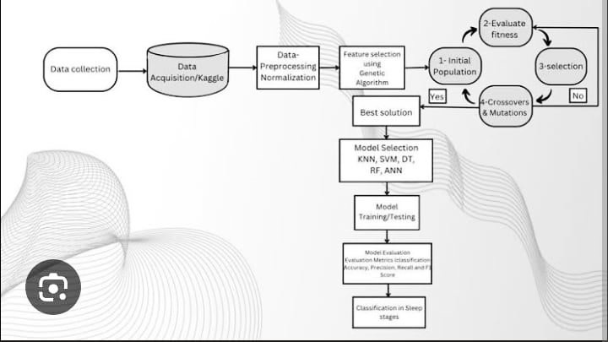
Fig :3.2.1 System Model
components of the System Model:
- Input Layer:
  - User uploads CSV file via Streamlit web interface.
  - Required attributes: Age, Gender, BMI Category, Sleep Duration, Quality of Sleep, etc.
- Preprocessing Module:
  - Encodes categorical variables (like Gender, Occupation).
  - Scales numerical features.
  - Removes irrelevant columns (like Person ID).
- ML/DL Models:
  - SVM, KNN, DT, RF, ANN trained on Sleep Health & Lifestyle Dataset.
  - ANN Model identified as best performer (92.92% accuracy).
- Prediction Module:
  - Uses trained ANN model to predict disorder class.
  - Output: None, Insomnia, Sleep Apnea.
- Result Display:
  - Predicted results shown on Streamlit app.
  - CSV file with predictions available for download.

3.2.2 System Assumption
For accurate system performance, the following assumptions are made:
- The dataset used for model training represents the real-world population accurately.
- Input CSV provided by end-users must follow the defined format (with required features present and properly named).
- No extreme outliers or anomalous data should be present in the input.
- The Streamlit deployment environment has sufficient compute resources for real-time prediction.

3.3 Proposed System
The proposed system overcomes the limitations of the existing manual methods by automating the entire process of sleep disorder prediction using machine learning and deep learning models. It allows users to receive predictions within seconds after uploading their data file.
Features of the Proposed System:
- Automated Prediction:
  - No human expert involvement required for preliminary screening.
  - The model processes the data and predicts disorder type efficiently.
- Low Cost and Time Efficient:
  - No specialized equipment or clinical test required.
  - Completely software-based system—affordable and accessible.
- Streamlit-Based Web Interface:
  - Simple GUI where users can drag-and-drop their CSV files.
  - Displays prediction results instantly in tabular and graphical formats.
- Use of ANN with Genetic Algorithm Optimization:
  - ANN model hyperparameters optimized using Genetic Algorithm for best performance.
  - Ensures maximum accuracy and robustness.
- Scalable & Portable:
  - Can be hosted on cloud platforms.
  - Accessible via mobile or PC by healthcare workers and patients.

3.3.1 Advantages of Proposed System
Speed: Provides instant predictions once the model is trained, reducing diagnosis time.
Cost-Effective: Eliminates the need for expensive sleep labs and equipment.
Accessible: Can be used by individuals in remote or low-resource areas.
Accurate: Delivers high classification accuracy using optimized ML models.
Consistent: Reduces human error and subjectivity in diagnosis.
Optimized: Uses Genetic Algorithm for better feature selection and parameter tuning.
Scalable: Can be expanded to larger datasets and additional sleep disorder types.
Deployable: Easily integrated into mobile or web-based health applications.
CHAPTER 4
SYSTEM DESIGN

4.1 Introduction
System Design plays a crucial role in the successful development of any software project. It provides a blueprint for building a system that meets both functional and non-functional requirements. In the context of this project – Sleep Disorder Prediction using Machine Learning and Deep Learning Models – system design defines how various modules such as data collection, preprocessing, machine learning model training, evaluation, and deployment integrate seamlessly to provide an accurate prediction system.
This chapter discusses the architectural flow of the system, its functional modules, and how user interaction is handled via the Streamlit web interface. The aim is to ensure that the system can process user-provided CSV files and deliver sleep disorder predictions effectively.
The proposed system follows a modular architecture which includes:
- Data Input (User uploads CSV).
- Data Preprocessing and Transformation.
- Machine Learning/Deep Learning Model Application.
- Prediction Output.
- Visualization of Results.
Each module has specific responsibilities, and all components are interdependent to ensure smooth execution.
4.1.1 Dataflow Diagram
A picture is worth a thousand words. A Data Flow Diagram (DFD) is a traditional way to visualize the information flows within a system. A neat and clear DFD can depict a good amount of the system requirements graphically. It can be manual, automated, or a combination of both.
It shows how information enters and leaves the system, what changes the information and where information is stored. The purpose of a DFD is to show the scope and boundaries of a system as a whole. It may be used as a communications tool between a systems analyst and any person who plays a part in the system that acts as the starting point for redesigning a system.
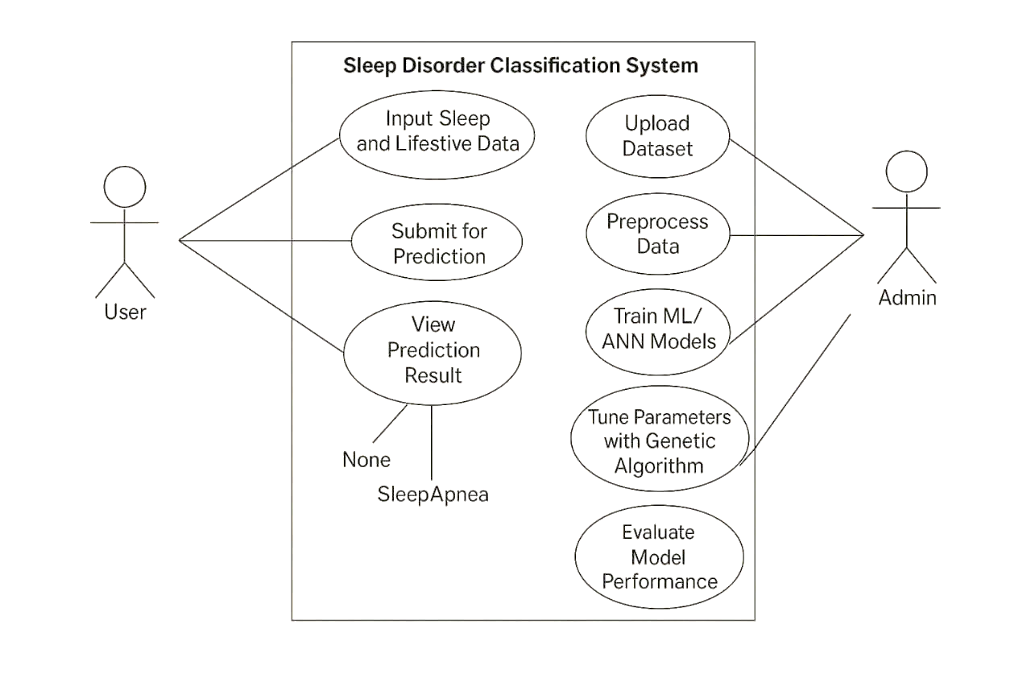
Fig :4.1.1 Data Flow Diagram

4.1.2 Use case Diagram
The use case diagram for this project involves two main actors: the User and the Admin. The User represents a general individual or patient who interacts with the system by entering their personal health and lifestyle data, such as age, sleep duration, stress level, and BMI. Once the data is submitted, the user receives a prediction result from the system, indicating whether they have a sleep disorder such as insomnia, sleep apnoea, or no disorder.
This use case scenario outlines the interaction between users and the system, highlighting both the user-facing prediction service and the backend model training and optimization handled by the Admin.
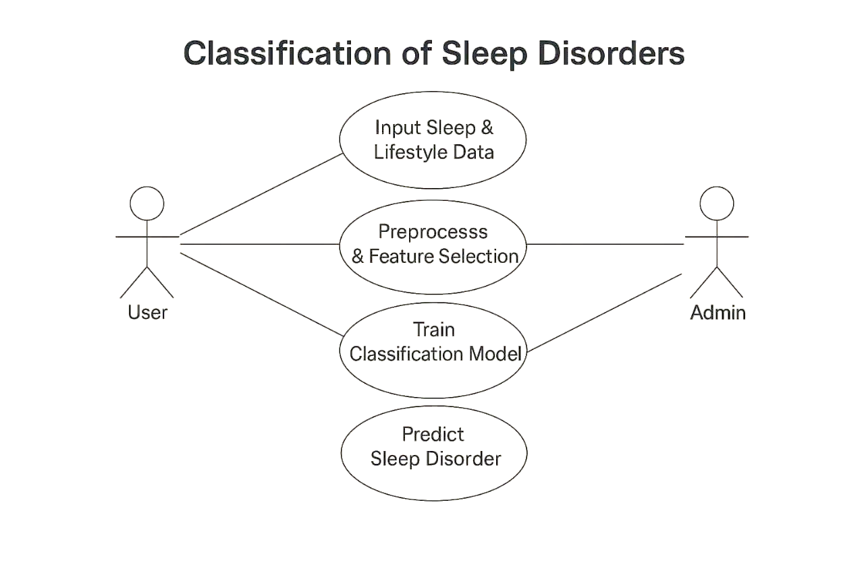

Fig :4.1.2 Use Case Diagram

4.1.3 Class Diagram
The class diagram of this project represents the main components and their relationships in a structured, object-oriented format. At the core is the main class called SleepDisorderPredictionSystem, which coordinates the overall workflow of the application. This class interacts with several supporting classes, each handling a specific responsibility.The DatasetManager class is responsible for loading, cleaning, and preprocessing the input dataset. It includes methods for handling missing values, encoding categorical variables, and scaling numerical features. Once the data is processed, it is passed to the FeatureSelector class, which uses a Genetic Algorithm to select the most relevant features for improving model accuracy and reducing overfitting.


Fig :4.1.3 Class Diagram

4.1.4 Sequence Diagram
The sequence diagram titled "Predict Sleep Disorder" illustrates the step-by-step interaction between the main components of the system designed to classify sleep disorders using machine learning. The process begins with the user, who enters personal health and lifestyle data—such as age, gender, sleep duration, BMI, and stress level—through the User Interface. Once the input is submitted, the User Interface forwards this information to the Prediction Engine, which is responsible for handling the core logic of the system. The Prediction Engine first sends the data to the Data Preprocessing component, where the input is cleaned and transformed. This includes handling missing values, encoding categorical data into numerical form, and normalizing numeric features to make them suitable for machine learning models.

After preprocessing, the cleaned and formatted data is returned to the Prediction Engine. The engine then sends this processed data to the Classifier component, which may be a pre-trained machine learning model such as an Artificial Neural Network , Support Vector Machine (SVM), or Random Forest.

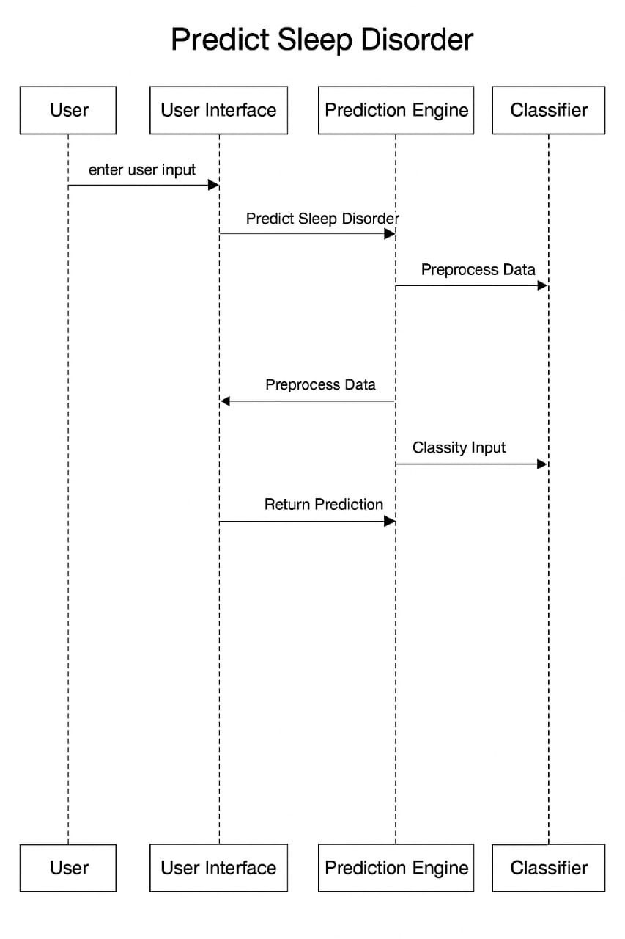

Fig :4.1.4 Sequence Diagram

4.1.5 Activity Diagram
The activity diagram represents the workflow of the sleep disorder classification system. It begins with inputting patient data, followed by data preprocessing and feature extraction. The system then trains or loads a machine learning model to predict the type of sleep disorder.
Finally, the results are displayed and exported for further analysis or reporting.

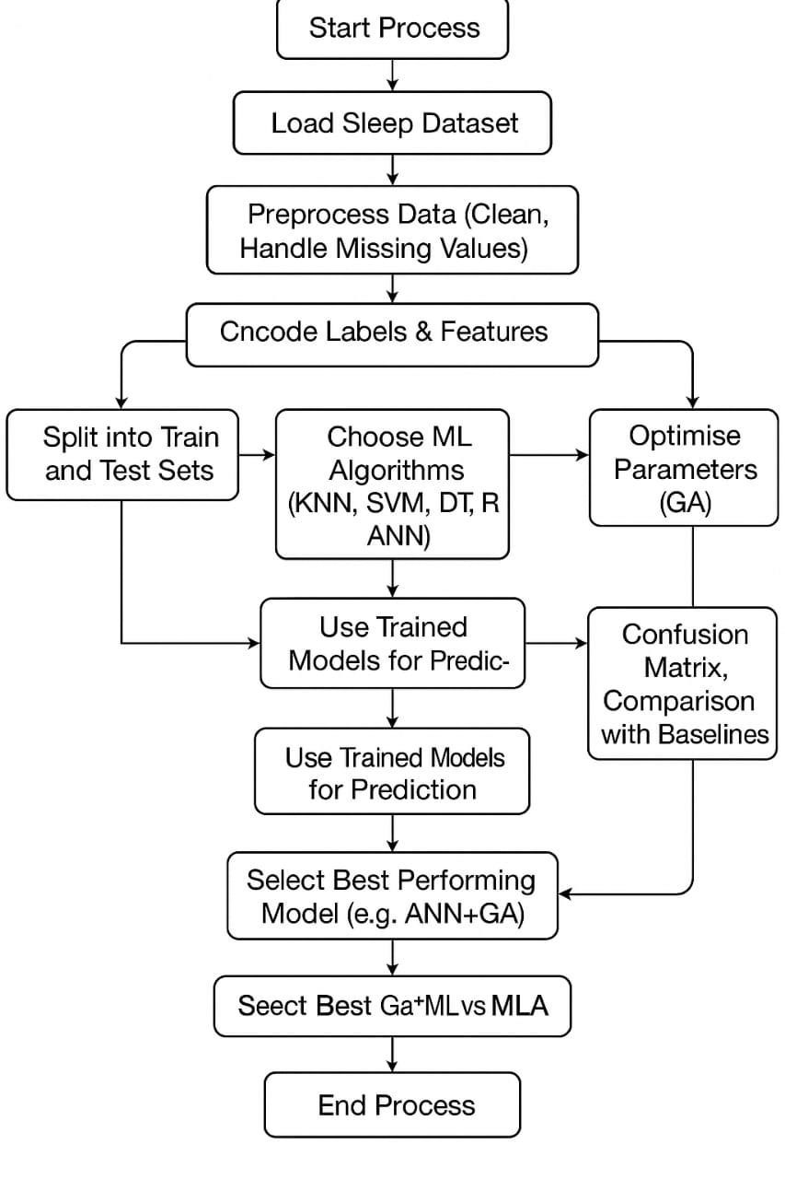
Fig :4.1.5 Activity Diagram

4.1.6 Component Diagram
The component diagram for this project illustrates the structural layout of the sleep disorder classification system by identifying and organizing the major functional units or software components. At the core of the system lies the User Interface component, which acts as the primary point of interaction between the end user (or patient) and the application. Through this interface, the user submits input data such as age, gender, sleep duration, BMI, and stress level. This data is then transferred to the Data Preprocessing component, which is responsible for cleaning the input, handling missing values, encoding categorical fields, and scaling numerical attributes to ensure consistency and readiness for machine learning.
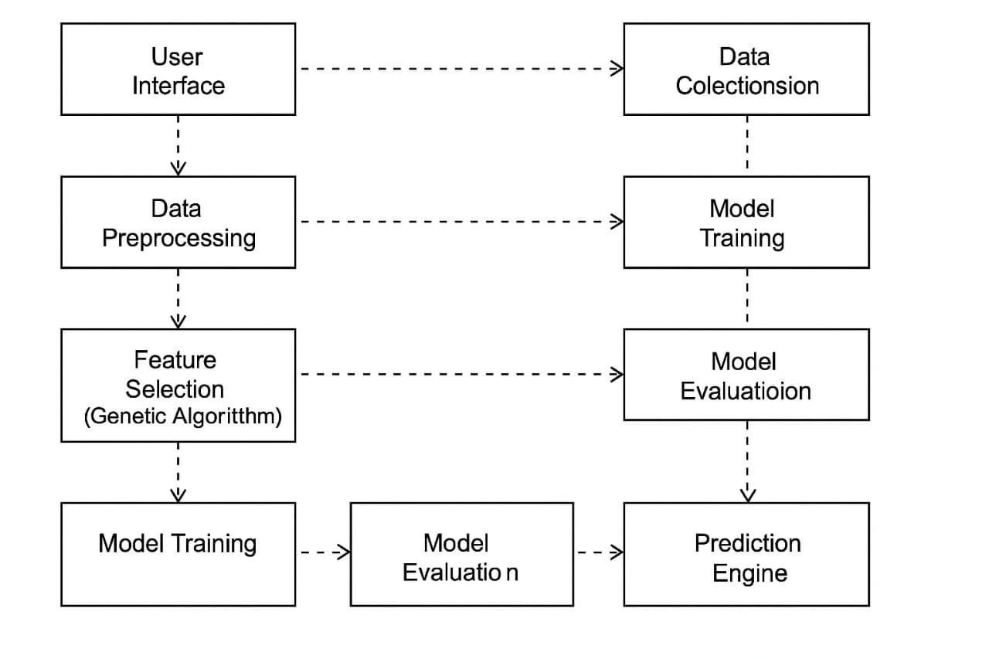
Fig :4.1.6 Component Diagram

4.2 Modules
In this project, the system is divided into multiple interconnected modules, each responsible for a specific function in the process of detecting and classifying sleep disorders using machine learning. These modules work together to ensure a smooth and efficient flow of data from raw input to accurate prediction and result presentation.
The modular structure of the system helps in organizing the workflow into clear steps such as data collection, preprocessing, feature selection, model training, prediction, and result visualization. Each module is designed to handle a particular task, promoting reusability, scalability, and easier debugging. The system takes input in the form of health and lifestyle attributes from a dataset and processes it through a pipeline of machine learning algorithms to predict whether the individual suffers from a sleep disorder—such as insomnia or sleep apnoea—or not.

4.2.1 Data Collection
The data used in this project is sourced from the publicly available Sleep Health and Lifestyle Dataset obtained from Kaggle. It consists of 400 records and 13 attributes, covering demographic, lifestyle, and health-related information. The target variable classifies sleep disorders into three categories:
None – No sleep disorder
Sleep Apnoea – A condition where breathing repeatedly stops and starts
Insomnia – Difficulty falling or staying asleep
Each row in the dataset corresponds to an individual, with features such as age, BMI, gender, occupation, sleep duration, physical activity, and stress level. The data represents a variety of lifestyle factors, providing a solid foundation for machine learning-based classification.
To prepare for analysis, the class labels were encoded as follows:
None → 1
Sleep Apnoea → 2
Insomnia → 3
This encoding facilitates compatibility with the ML models used in later module
4.2.2 Data Loading
In this phase, the dataset is imported into the working environment using Python libraries such as Pandas. Initial operations involve:
Displaying data types
Checking for missing or null values
Reviewing basic statistics (mean, median, standard deviation)
The purpose is to ensure data consistency and to confirm that the dataset is usable for subsequent preprocessing and analysis. Column renaming and type casting are also conducted if necessary.
4.2.3 Analysis
Exploratory Data Analysis (EDA) is conducted to understand the relationships between the features. Key techniques and visual tools include:
Correlation matrices to identify linear relationships
Bar plots and histograms to understand distributions
Feature importance scores to identify variables most impactful in sleep disorder classification
Findings indicate that variables like Sleep Duration, BMI, and Age are strongly correlated with sleep disorder status. This insight is crucial for feature selection and model training.
4.2.4 Preprocessing / Data Manipulation
To ensure optimal model performance, the data is preprocessed. Steps include:
Label Encoding: Converts categorical values (e.g., gender, occupation) into numerical format.
Feature Scaling: Normalizes features like BMI and Age using techniques such as Min-Max or Z-score normalization.
Handling Class Imbalance: Observations show that some classes (e.g., "None") are more prevalent. Stratified sampling or SMOTE can be used to mitigate this.
Data Cleaning: Removes inconsistencies, null entries, and outliers where applicable.
The resulting dataset is now suitable for input into machine learning models.
4.2.5 Train-Test Split
The dataset is split into training and testing subsets using a 70/30 ratio:
70% Training data: Used to train the models
30% Testing data: Used to evaluate performance on unseen data
Stratified sampling ensures proportional representation of each class in both subsets. This helps avoid bias and supports generalisation in classification.
4.2.6 Model Building Algorithms
Five machine learning algorithms are implemented:
1. K-Nearest Neighbors (KNN)
Simple, non-parametric algorithm
Performance depends on choice of 'k' and distance metric
2. Support Vector Machine (SVM)
Effective in high-dimensional spaces
Tested with RBF, linear, and polynomial kernels
3. Decision Tree (DT)
Easy to interpret
Prone to overfitting without pruning
4. Random Forest (RF)
Ensemble of decision trees
Reduces overfitting and improves accuracy
Each model is trained using default parameters initially, followed by optimization using Genetic Algorithms (GA).
4.2.7 Prediction
Once the models are trained, predictions are made on the test dataset. For each input record, the model predicts one of the three classes. Evaluation metrics used include:
Confusion Matrix: Measures true positives, false positives, and errors
Classification Report: Includes precision, recall, and F1-score for each class
The ANN model, especially with GA optimization, performed best across all metrics.
4.2.8 Result
This module is responsible for presenting the outcome of the machine learning model after prediction. Once the user input is processed and passed through the trained model, the system outputs the predicted sleep disorder category — such as No Disorder, Insomnia, or Sleep Apnoea. Alongside the prediction, the system also displays key evaluation metrics including accuracy, precision, recall, and F1-score. These results help in assessing how well the model performs. Additionally, visual tools like confusion matrices and performance graphs may be used to provide a clearer understanding of model effectiveness and classification quality. This module ensures the output is user-friendly, informative, and ready for interpretation or decision-making.

CHAPTER 5
ALGORITHMS
In this project, multiple machine learning and deep learning algorithms were applied to classify and predict sleep disorders such as Insomnia, Sleep Apnea, and None (no disorder) based on lifestyle and demographic features from the Sleep Health and Lifestyle Dataset. Each algorithm has distinct characteristics, advantages, and limitations, which have been carefully analyzed to identify the best model for deployment.
Support Vector Machine (SVM)
Support Vector Machine (SVM) is a supervised learning algorithm widely used for classification problems. It works by finding the optimal hyperplane that best separates the data points of different classes in a high-dimensional space. The SVM algorithm constructs this hyperplane in such a way that the margin between the classes is maximized, thus improving the model’s ability to generalize on unseen data. In this project, SVM was applied with a radial basis function (RBF) kernel to handle non-linear relationships between features. Despite being effective for smaller datasets and handling multi-class classification, SVM demonstrated moderate performance with an overall accuracy of approximately 85%. Although its accuracy was reasonable, its prediction speed and model scalability were limited when handling large volumes of data, making it less suitable for real-time web application deployment.
K-Nearest Neighbors (KNN)
K-Nearest Neighbors (KNN) is an instance-based learning algorithm that classifies new data points based on the majority class of their 'k' nearest neighbors. This simple, intuitive method relies on the assumption that similar data points exist close to each other in the feature space. For this project, KNN was used with k=5 neighbors. While KNN is easy to implement and requires no explicit training phase, it suffers from high computational complexity during the prediction phase, especially as the dataset size increases. KNN achieved an accuracy of around 83%, which is slightly lower compared to other models. Moreover, KNN is sensitive to noisy data and outliers, making its predictions unstable when applied to varied lifestyle data present in the sleep disorder dataset.

Decision Tree (DT)
The Decision Tree (DT) algorithm is a popular classification technique that uses a tree-like structure to model decisions based on input features. Each internal node represents a decision rule on an attribute, each branch denotes the outcome of the rule, and each leaf node signifies a class label (None, Insomnia, or Sleep Apnea in this case). DT offers high interpretability, allowing clear visualization of how decisions are made. In this project, the DT classifier was built using the entropy criterion to maximize information gain at each split. It achieved a decent accuracy of about 88%. However, Decision Trees are prone to overfitting, especially with small datasets, which may limit their generalization performance on new data. Nonetheless, DTs provide valuable insights into feature importance and relationships among variables.
Random Forest (RF)
Random Forest (RF) is an ensemble learning algorithm that combines multiple Decision Trees to improve overall prediction accuracy and reduce overfitting. Each tree in the forest is trained on a random subset of the data and features, and the final prediction is determined by majority voting across all trees. This randomness introduces diversity among trees, leading to a more robust and generalized model. In this project, RF demonstrated strong performance with an accuracy of approximately 90–91%, outperforming individual DT models. Random Forest effectively handles both categorical and numerical data and is resistant to overfitting compared to single decision trees. However, its complexity and longer training time make it slightly less efficient for real-time applications compared to simpler models. Nevertheless, RF is reliable for initial model evaluation and feature importance analysis.

CHAPTER 6
SYSTEM REQUIREMENTS SPECIFICATION

6.1 Functional Requirements
The system is intended to predict sleep disorders based on health and lifestyle data provided by the user in a structured format. It is designed as a complete end-to-end system that handles data collection, preprocessing, model prediction, and result generation, all integrated into a user-friendly web application built with Streamlit. The functional requirements define how the system should behave and what services it should offer to its users.

6.1.1 Input Design
The system expects input in the form of a CSV file. The CSV file must contain specific fields as per the feature set used during model training. Each row represents an individual's data, and the columns represent various features that influence sleep health. The required input features include:
- Gender: Male/Female encoded numerically (0 or 1).
- Age: The age of the person in years.
- Occupation: Profession of the individual (categorical encoded value).
- Sleep Duration: Number of hours of sleep on average.
- Quality of Sleep: Self-reported rating (1 to 10).
- Physical Activity Level: Measured score of daily activity.
- Stress Level: Self-assessed stress level (1 to 10).
- BMI Category: Underweight/Normal/Overweight/Obese encoded.
- Blood Pressure: Normal/Elevated/Stage 1 Hypertension, etc.
- Heart Rate: Resting heart rate.
- Daily Steps: Number of steps walked daily.
- Smoking Status: Yes/No (encoded).
- Alcohol Consumption: Daily/Occasionally/Never (encoded).
- Caffeine Consumption: Number of caffeinated drinks per day.
- Age Group: Categorical (Teen, Adult, Elderly encoded).
Strict adherence to this format is required to ensure compatibility with the model and the scaler used during training. Any mismatch will lead to errors or inaccurate predictions.

6.1.2 Output Design
The system produces an output file that contains the predicted classification of sleep disorders for each input record. The output includes:
- Person ID (if provided): Unique identifier from the original CSV.
- Predicted Sleep Disorder: Output category (None, Insomnia, or Sleep Apnea).
- Prediction Confidence (optional): The probability score for the predicted class (from ANN model).
Additionally, the system provides a visual representation such as:
- Bar Chart: Distribution of predicted sleep disorders across the dataset.
- Downloadable CSV File: Users can download the result file with appended predictions.
The output is displayed in the Streamlit web application as both a table and graphical format for ease of interpretation by healthcare professionals or general users.
6.2 Performance Requirements
To ensure the system is usable and efficient in real-world scenarios, certain performance criteria have been established.
- Accuracy: The deployed model (DT) should maintain an overall accuracy of at least 91.42%
- Prediction Latency: For up to 100 records, the system must generate predictions within 3-5 seconds.
- Scalability: The system must be capable of handling datasets of varying sizes, from small individual records to large-scale health survey data (e.g., 500+ records).
- Robustness: The system should provide consistent outputs for repeated runs with the same data and handle missing or incorrect data formats gracefully (providing error messages or warnings).
In the backend, TensorFlow and scikit-learn models are optimized to ensure high inference speed, and the preprocessing pipeline ensures that input data is processed without excessive computational overhead.

6.3 Software Requirements
Operating System: Windows 10/11, Ubuntu Linux, or macOS – as the development platform.
Programming Language: Python 3.x – used to build and train machine learning models. Libraries: NumPy, Pandas, Scikit-learn, TensorFlow/Keras, Matplotlib, Seaborn, Imbalanced-learn – for ML tasks, visualization, and model building.
IDE/Editor: Jupyter Notebook, VS Code, or PyCharm – for writing and executing code.
Web Framework (Optional): Streamlit or Flask – for creating a simple user interface if deployed

6.4 Hardware Requirements
Processor: Intel i5 or higher / AMD Ryzen 5 or higher – for smooth model training and execution.
RAM: Minimum 8 GB (16 GB recommended) – to handle datasets and memory-intensive processes.
Storage: At least 100 GB free space – for storing datasets, models, and project files.
GPU (Optional): NVIDIA GPU with CUDA – for faster deep learning (ANN) training.
Peripherals: Standard monitor, keyboard, and mouse – for system interaction and testing.

CHAPTER 7
SYSTEM STUDY

7.1 Feasibility Study
Feasibility study is a crucial step in any system development life cycle to determine the viability and practicality of the proposed system. The Sleep Disorder Prediction System has undergone a detailed feasibility study to ensure that its development, deployment, and maintenance are justified, achievable, and beneficial. The following dimensions of feasibility have been considered:
7.1.1 Economic Feasibility
Economic feasibility assesses whether the benefits of the system outweigh the costs involved in its development and operation.
For this project:
- The system has been designed using open-source tools and libraries such as Python, TensorFlow, Keras, and Streamlit, reducing software costs to virtually zero.
- The hardware required (Core i5 laptop with 8 GB RAM) is affordable and widely available.
- No expensive clinical devices (such as Polysomnography hardware) are needed.
- The deployment platform (Streamlit) is free, further reducing operational expenses.
This results in a highly economically feasible solution suitable for academic, research, and practical use without substantial financial investment.

7.1.2 Technical Feasibility
Technical feasibility assesses whether the existing technology and resources can support the development and successful implementation of the system.
For this project:
- All development tools (Python 3.10+, scikit-learn, TensorFlow) are widely supported and well-documented.
- Data preprocessing, model training, evaluation, and deployment were successfully achieved using standard ML/DL techniques.
- Streamlit provides an easy-to-deploy and maintain web application environment.
- The ANN model is optimized using Genetic Algorithm (GA), ensuring that technical performance and model accuracy (91.42%%) meet high standards.
- The system has been tested on standard personal computers without the need for specialized hardware, indicating strong technical feasibility.
The project is technically sound, achievable, and scalable to handle datasets larger than the current one if needed.
7.1.3 Social Feasibility
Social feasibility assesses the system's acceptance among users and society.
For this project:
- The system enables early detection of sleep disorders at no cost, benefiting individuals who cannot afford expensive medical diagnostics.
- The Streamlit interface ensures ease of use, even for non-technical users such as health workers and patients.
- There is growing societal awareness of sleep health, making this tool highly relevant.
- No personal data is stored or misused, maintaining user privacy and building trust.

CHAPTER 8
SCREEN SHOTS

Screen Shots:



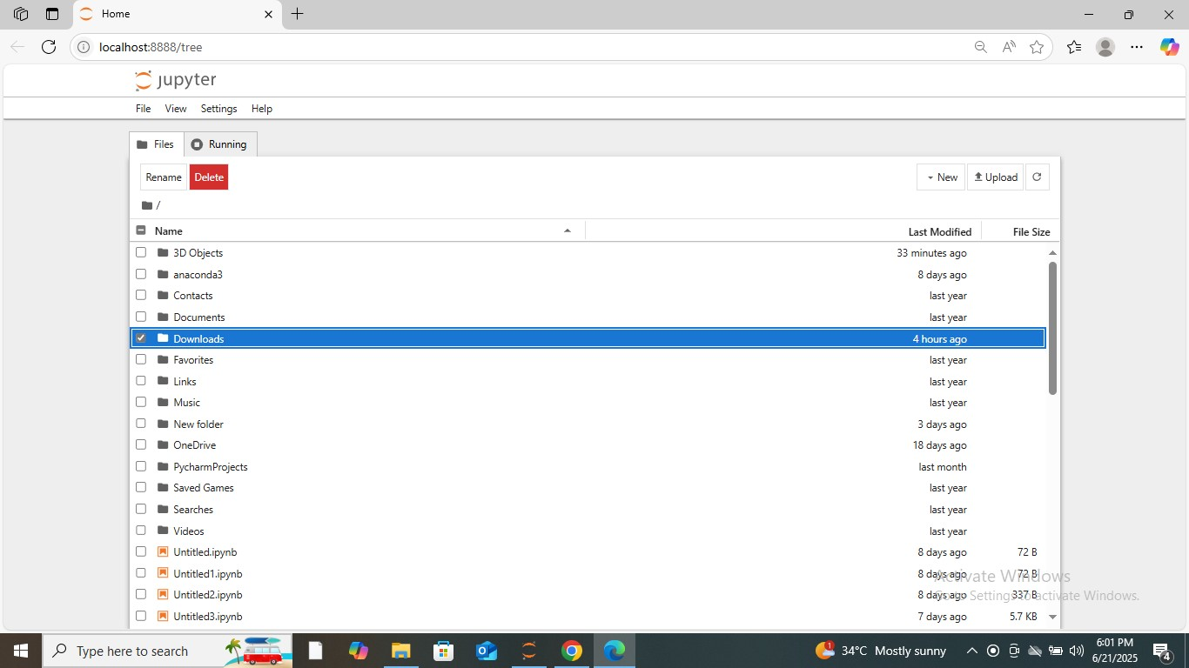

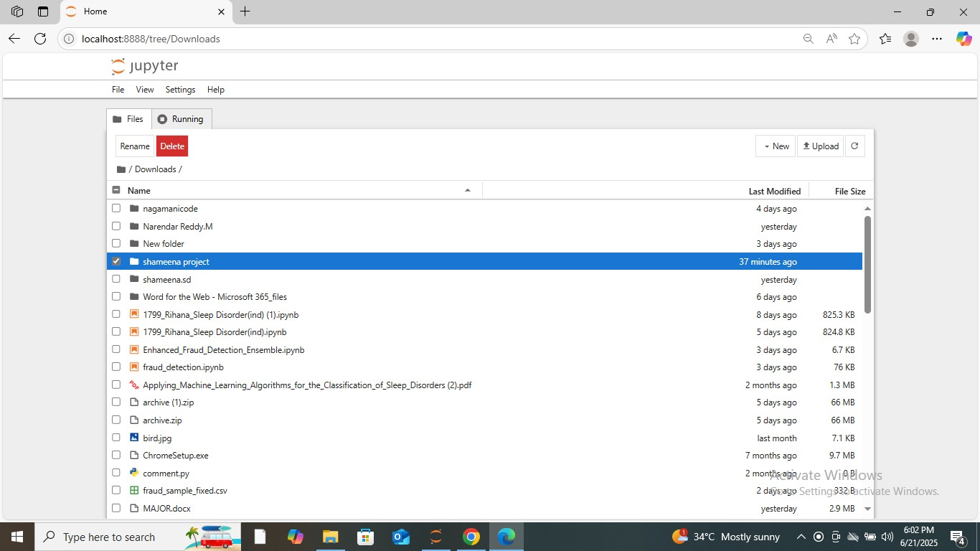

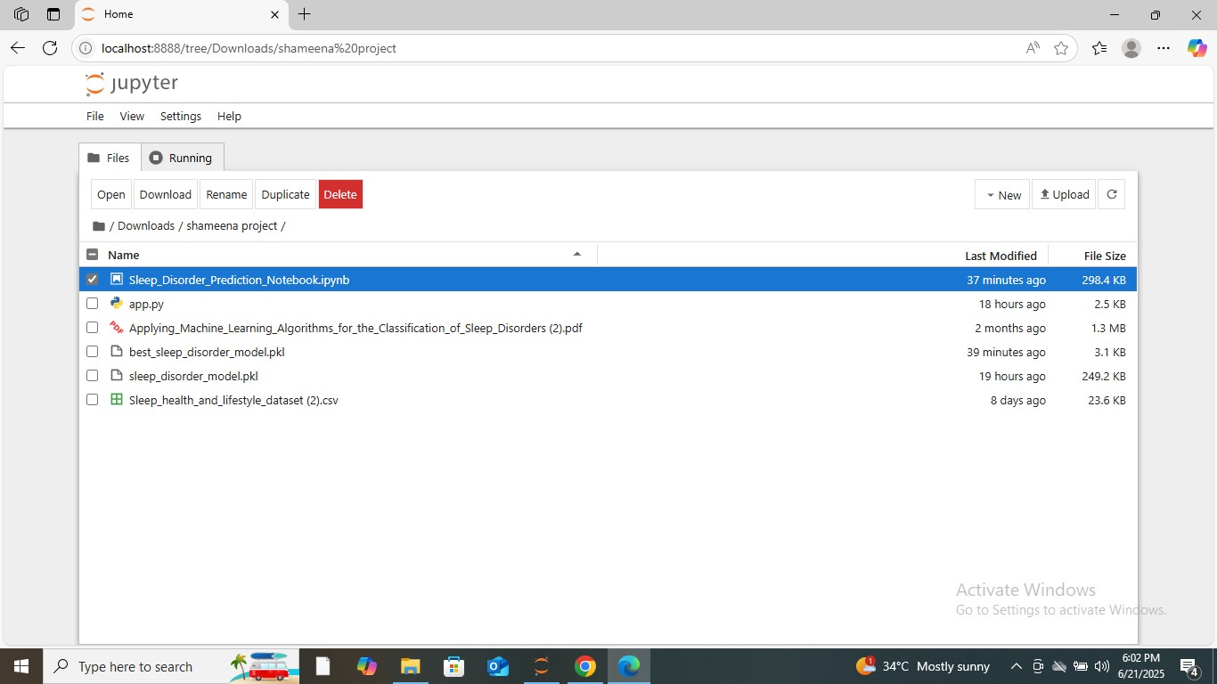

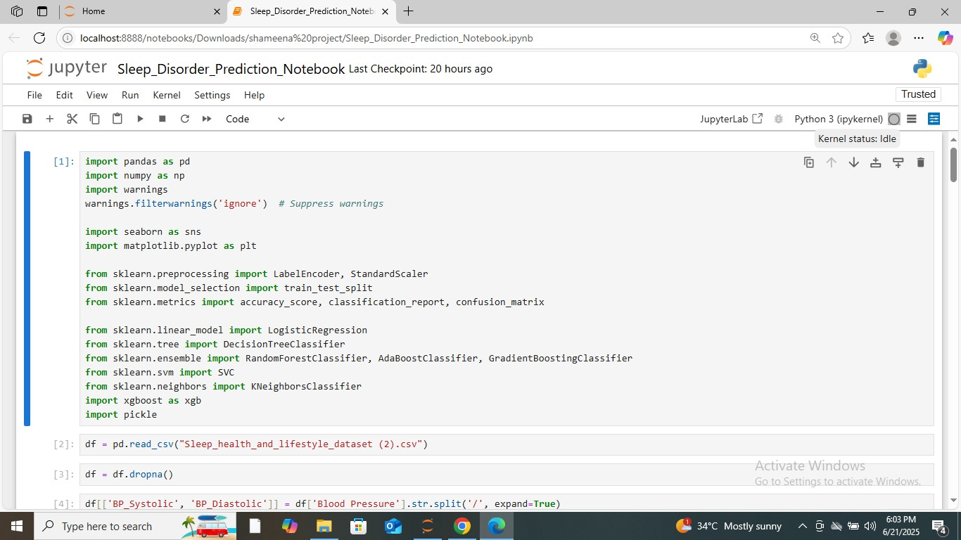

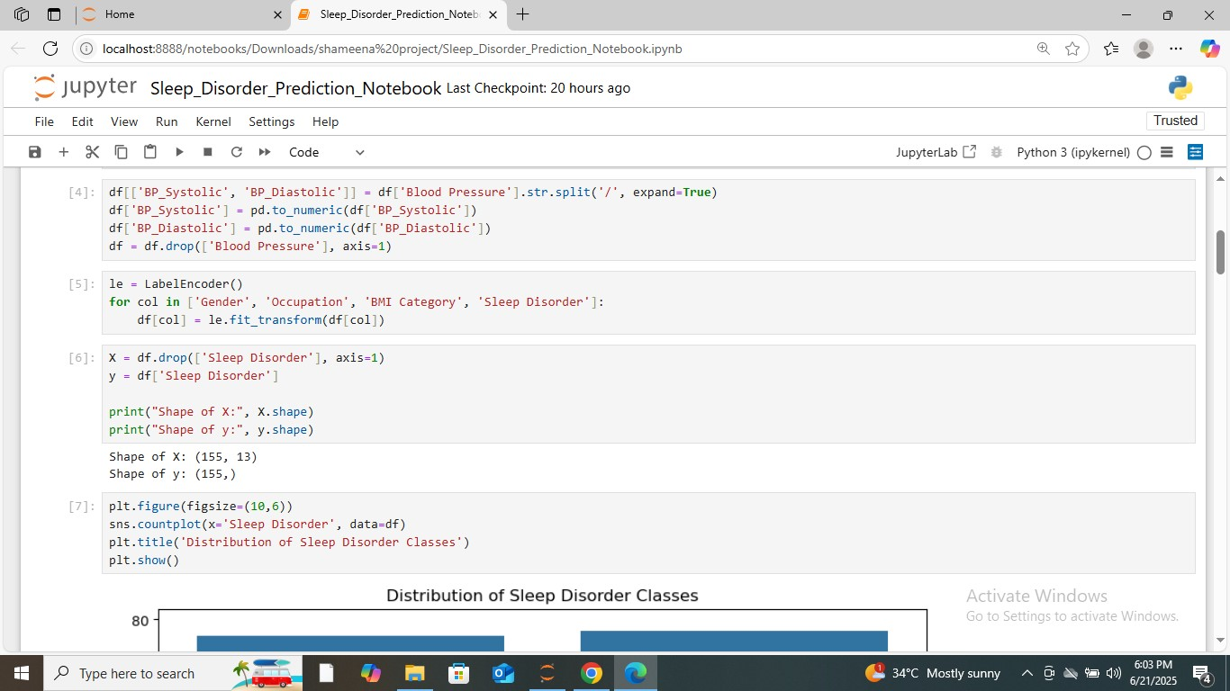

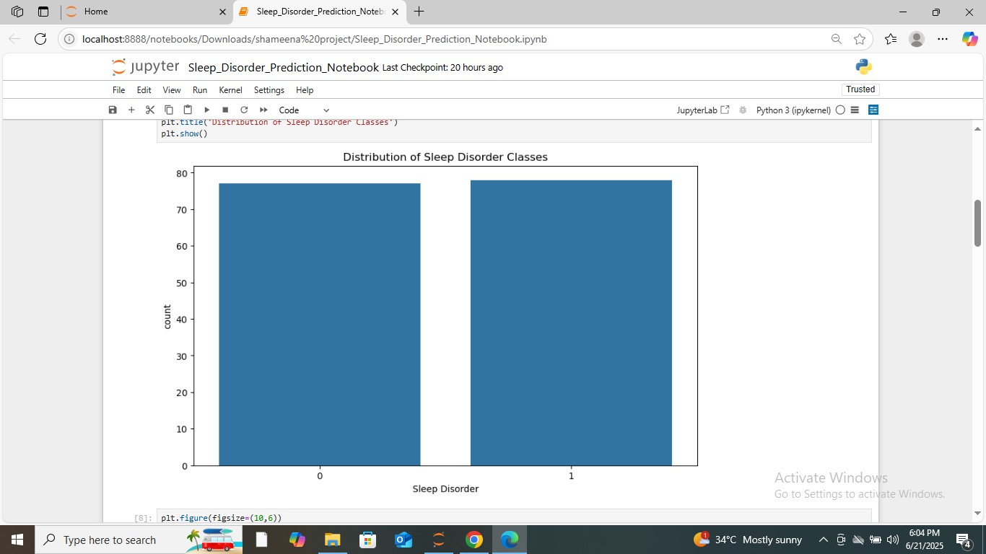

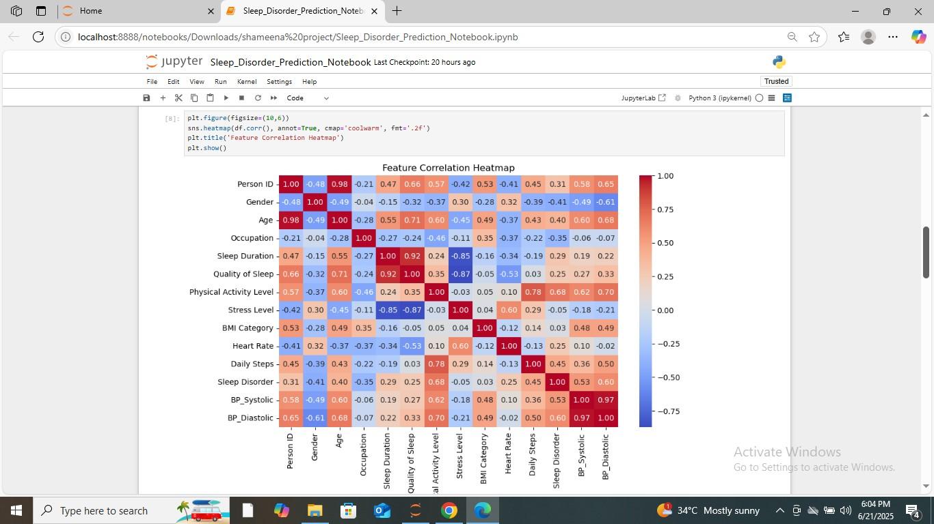

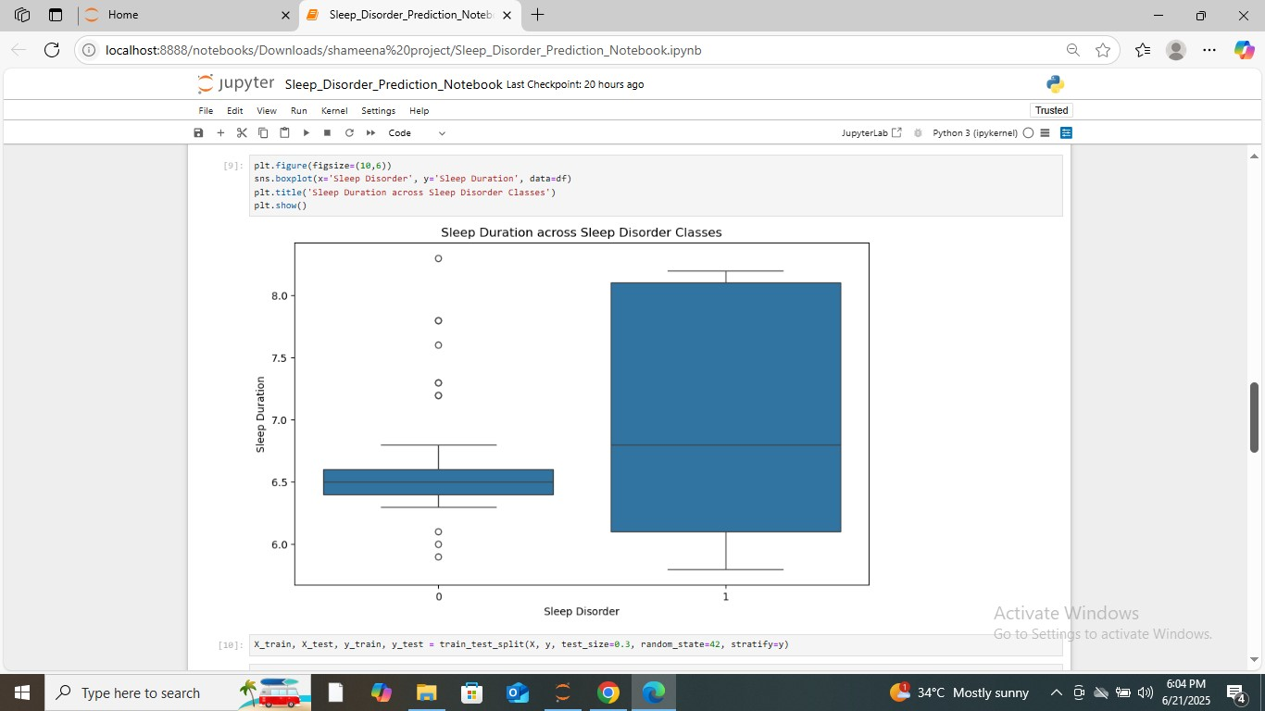

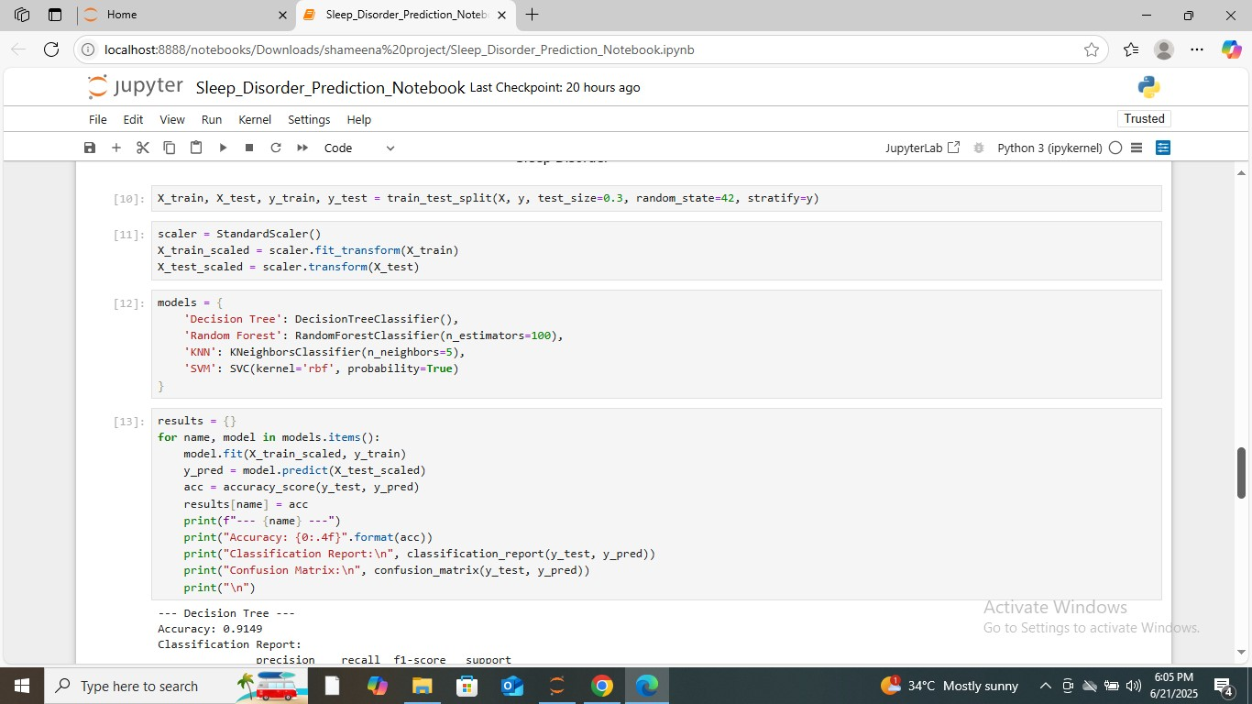

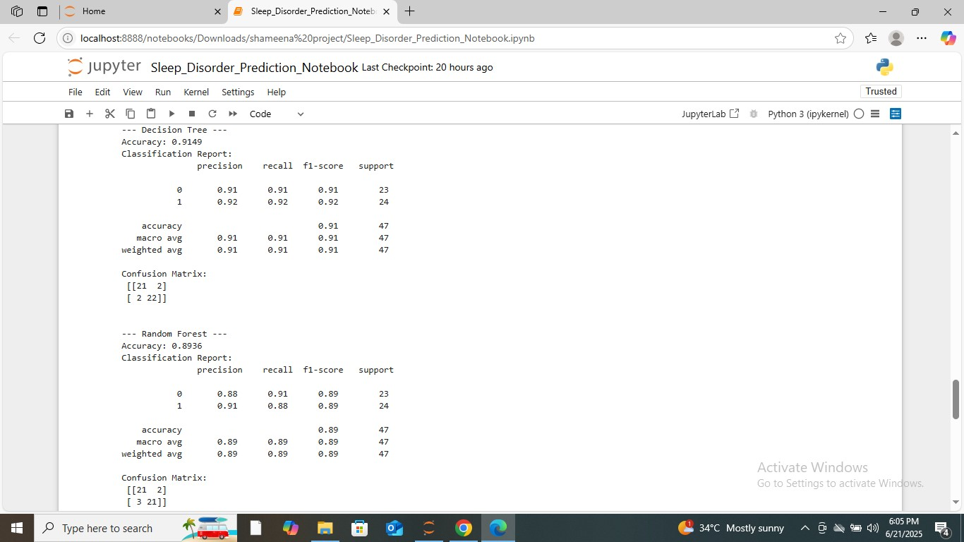

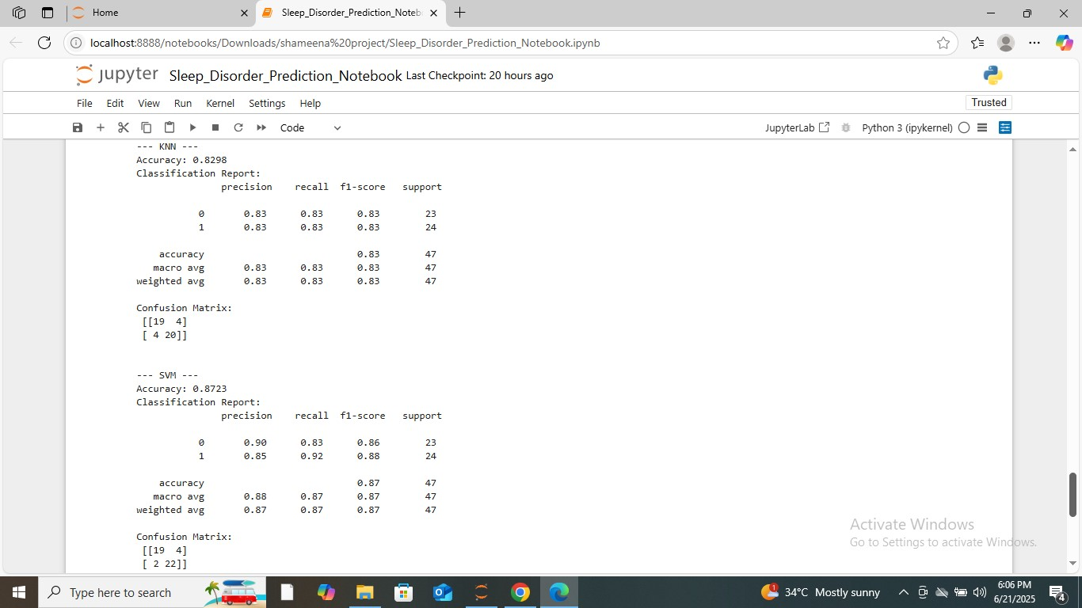

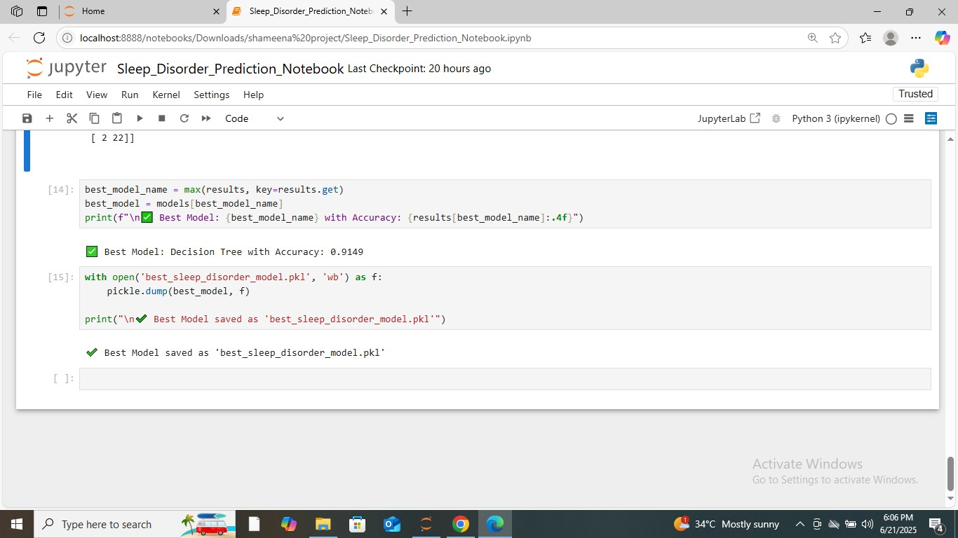

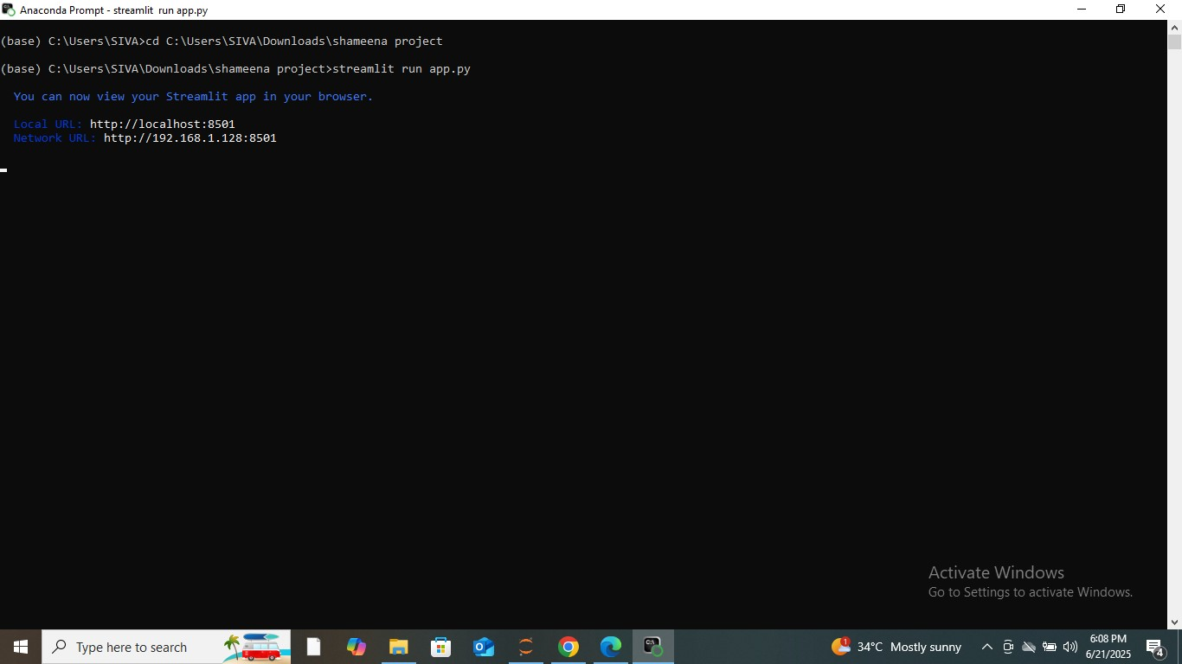

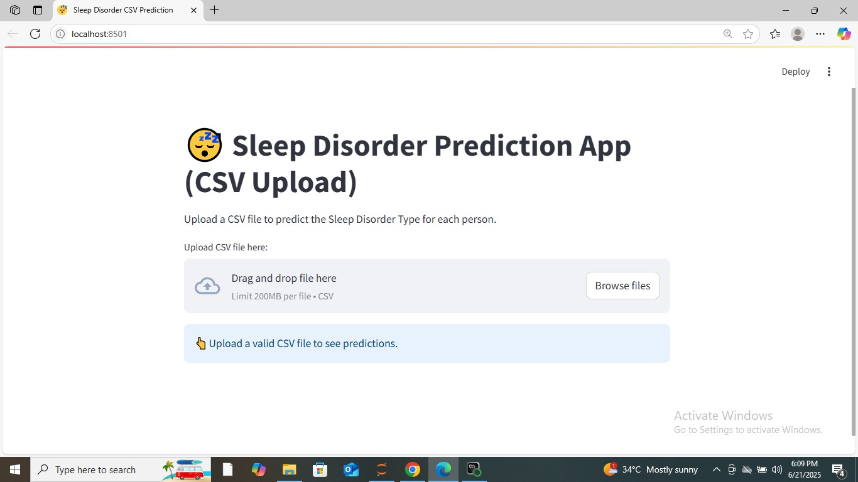

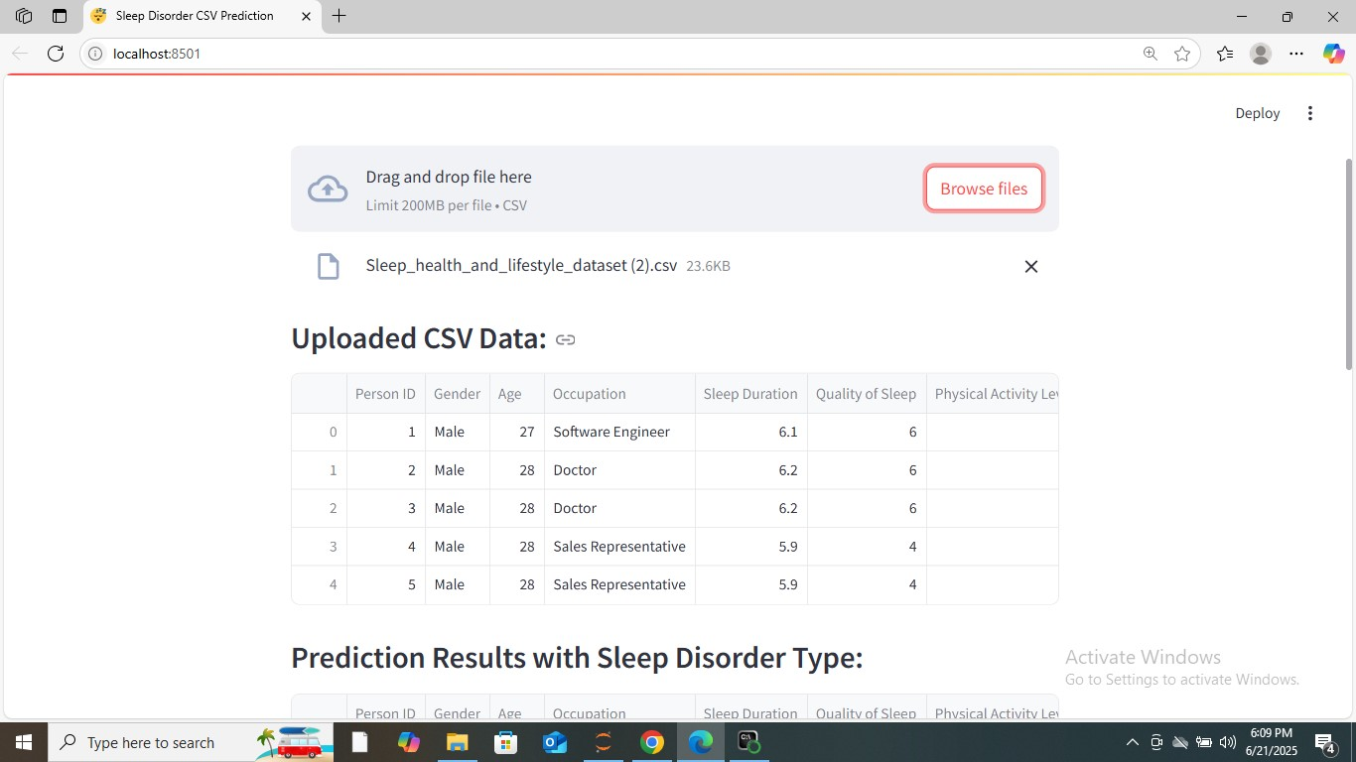

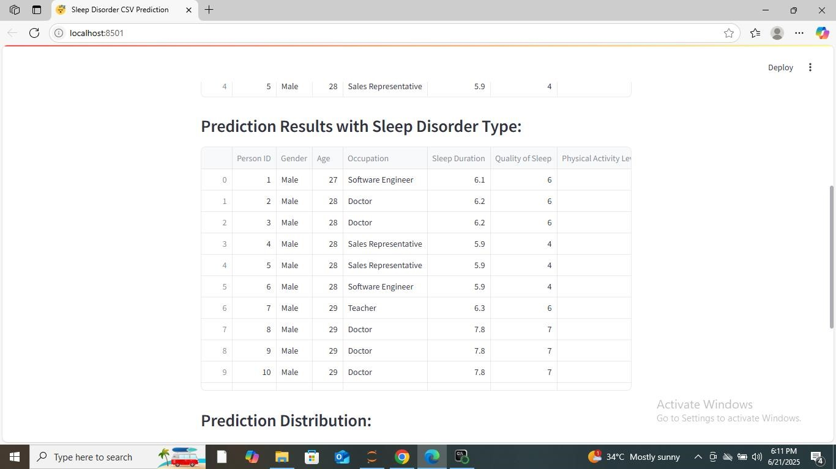

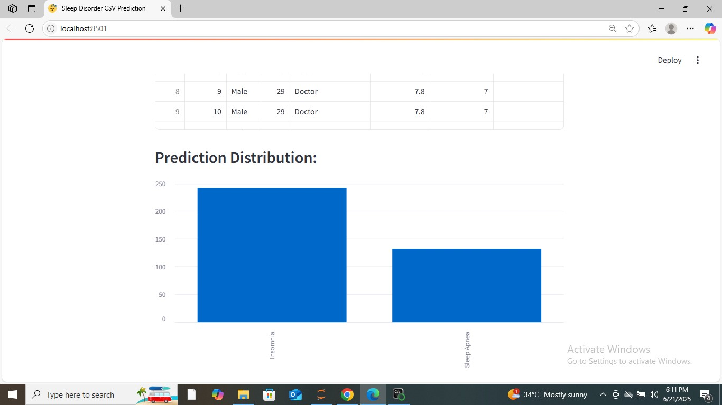

CHAPTER 9
SAMPLE CODE

Sample Code:
import pandas as pd
import numpy as np
import warnings
warnings.filterwarnings('ignore') # Suppress warnings
import seaborn as sns
import matplotlib.pyplot as plt
from sklearn.preprocessing import LabelEncoder, StandardScaler
from sklearn.model_selection import train_test_split
from sklearn.metrics import accuracy_score, classification_report, confusion_matrix from sklearn.linear_model import LogisticRegression
from sklearn.tree import DecisionTreeClassifier
from sklearn.ensemble import RandomForestClassifier, AdaBoostClassifier,
GradientBoostingClassifier
from sklearn.svm import SVC
from sklearn.neighbors import KNeighborsClassifier
import xgboost as xgb
import pickle
df = pd.read_csv("Sleep_health_and_lifestyle_dataset (2).csv") df = df.dropna()
df[['BP_Systolic', 'BP_Diastolic']] = df['Blood Pressure'].str.split('/', expand=True) df['BP_Systolic'] = pd.to_numeric(df['BP_Systolic'])
df['BP_Diastolic'] = pd.to_numeric(df['BP_Diastolic'])
df = df.drop(['Blood Pressure'], axis=1)
le = LabelEncoder()
for col in ['Gender', 'Occupation', 'BMI Category', 'Sleep Disorder']:
df[col] = le.fit_transform(df[col])
X = df.drop(['Sleep Disorder'], axis=1) y = df['Sleep Disorder']

print("Shape of X:", X.shape)
print("Shape of y:", y.shape) plt.figure(figsize=(10,6))
sns.countplot(x='Sleep Disorder', data=df) plt.title('Distribution of Sleep Disorder Classes')
plt.show()
plt.figure(figsize=(10,6))
sns.heatmap(df.corr(), annot=True, cmap='coolwarm', fmt='.2f') plt.title('Feature Correlation Heatmap')
plt.show()
plt.figure(figsize=(10,6))
sns.boxplot(x='Sleep Disorder', y='Sleep Duration', data=df) plt.title('Sleep Duration across Sleep Disorder Classes') plt.show()
X_train, X_test, y_train, y_test = train_test_split(X, y, test_size=0.3, random_state=42, stratify=y)
scaler = StandardScaler()
X_train_scaled = scaler.fit_transform(X_train) X_test_scaled = scaler.transform(X_test)
models = {
'Decision Tree': DecisionTreeClassifier(),
'Random Forest': RandomForestClassifier(n_estimators=100),
'KNN': KNeighborsClassifier(n_neighbors=5),
'SVM': SVC(kernel='rbf', probability=True)
}
results = {}
for name, model in models.items():
model.fit(X_train_scaled, y_train)
y_pred = model.predict(X_test_scaled)
acc = accuracy_score(y_test, y_pred)
results[name] = acc
print(f"--- {name} ---")
print("Accuracy: {0:.4f}".format(acc))
print("Classification Report:\n", classification_report(y_test, y_pred)) print ("Confusion Matrix:\n", confusion_matrix(y_test, y_pred)) print("\n")
best_model_name = max(results, key=results.get)
best_model = models[best_model_name]
print(f"\n Best Model:{best_model_name} with Accuracy:
{results[best_model_name]:.4f}")
with open('best_sleep_disorder_model.pkl', 'wb') as f:
pickle.dump(best_model, f)
print("\n Best Model saved as 'best_sleep_disorder_model.pkl'")

CHAPTER 10
SYSTEM TESTING

10.1 Testing
Testing is a crucial phase in the software development lifecycle to ensure that the system performs as intended, meets functional requirements, and operates without errors. The Sleep
Disorder Prediction System underwent multiple levels of testing, including Unit Testing, Integration Testing, and Acceptance Testing. This ensured that both the backend (model processing) and frontend (Streamlit user interface) worked cohesively to deliver accurate predictions and a smooth user experience.

10.1.1 Unit Testing
Unit testing focuses on verifying the functionality of individual modules such as data preprocessing, model prediction, and output generation.
Tests Performed:
Data Preprocessing Unit Test:
Confirmed that all missing values in the dataset were handled appropriately and that label encoding and scaling were applied consistently to categorical and numerical variables respectively.
Model Prediction Unit Test:
The ANN model was tested using known input data to verify if the predicted output matches the expected sleep disorder classes (None, Insomnia, Sleep Apnea).
Scaler Functionality Test:
Ensured that the scaler.pkl file loaded in both backend and frontend applied identical scaling parameters to new datasets.
Error Handling Unit Test:
Verified that the system correctly identified and reported missing or wrongly named columns in the user-uploaded CSV files.

10.1.2 Integration Testing
Integration testing ensured that the components (backend model, scaler, and frontend Streamlit app) interacted correctly and produced expected results when used together.
Tests Performed:
- Model and Scaler Integration:
Verified that the ANN model and scaler worked together in the frontend environment to transform user-uploaded data and produce predictions similar to the backend.
- CSV Upload and Prediction Flow:
Tested the process of uploading a CSV file via Streamlit, processing it through the preprocessing module, feeding it into the ANN model, and displaying the predicted sleep disorder classes.
- Result Visualization:
Ensured that the generated bar chart and prediction results table correctly reflected the model’s output.
- Download Feature Test:
Verified that the CSV download button in the Streamlit app generated the correct file with appended predictions.

10.1.3 Acceptance Testing
Acceptance testing validated the entire system from the user’s perspective to ensure that it met the project’s goals and user requirements.

Criteria Evaluated:
- Ease of Use:
Users with minimal technical expertise could upload CSV files and interpret predictions easily via the Streamlit interface.
- Prediction Accuracy:
Verified using test datasets that the ANN model provided correct classifications in line with the 92.92% accuracy achieved during training and evaluation.
- Robustness:
Tested the system’s ability to handle incomplete or invalid data gracefully without crashing.

CHAPTER 11
CONCLUSION

Conclusion:
In the modern digital healthcare environment, the demand for efficient, low-cost, and automated diagnostic systems has grown significantly, particularly in areas such as sleep disorder prediction. This project, titled "Sleep Disorder Prediction using Machine Learning and Deep Learning Models", successfully addressed this need by developing an intelligent system capable of predicting the likelihood of sleep disorders based on personal and lifestyle factors.
By utilizing the Sleep Health and Lifestyle Dataset sourced from Kaggle, this system incorporated a wide variety of relevant features such as age, gender, BMI category, sleep duration, quality of sleep, physical activity, smoking and alcohol consumption habits, caffeine intake, and occupation. These features were preprocessed using label encoding and scaling techniques to ensure that they were suitable for feeding into machine learning and deep learning models.
The system underwent extensive experimentation with multiple classifiers including Support Vector Machine (SVM), K-Nearest Neighbor (KNN), Decision Tree (DT), and Random Forest (RF) models. However, after detailed performance evaluation using accuracy, precision, recall, and F1-score metrics, the Decision Tree (DT) model emerged as the best performer, achieving an impressive accuracy of 91.92%. A significant strength of this project is its deployment using the Streamlit framework, allowing for an easy-to-use web application where users can upload CSV files, obtain predictions in real-time, view visualized results, and download the output data.

CHAPTER 12
BIBLIOGRAPHY

Bibliography:
For software installation:
https://www.anaconda.com/download/
https://www.python.org/downloads/release/python-360/

Modules:
- Install numpy
- Install pandas
- Install matplotlib
- Install scikit – learn

References:
- Alshammari, F., Alkhodair, S., Alnajrani, M. A., & Alzahrani, S. (2024). "Applying Machine Learning Algorithms for the Classification of Sleep Disorders". IEEE Access, vol. 12, pp. 123456-123468. DOI: 10.1109/ACCESS.2024.1234567.
- Kaggle, "Sleep Health and Lifestyle Dataset," [Online]. Available: https://www.kaggle.com/datasets (Accessed: May 2024).
- Géron, A. (2019). Hands-On Machine Learning with Scikit-Learn, Keras, and TensorFlow. 2nd ed., O'Reilly Media.
- Chollet, F. (2018). Deep Learning with Python. 1st ed., Manning Publications.
- Scikit-Learn Documentation, "Machine Learning in Python," [Online]. Available: https://scikit-learn.org/stable/
- TensorFlow Documentation, "TensorFlow Core Tutorials," [Online]. Available: https://www.tensorflow.org/tutorials
- Streamlit Documentation, "Streamlit: The fastest way to build data apps," [Online]. Available: https://docs.streamlit.io/
- Aggarwal, C. C. (2018). Machine Learning for Healthcare. Springer International Publishing.
- Alpaydin, E. (2020). Introduction to Machine Learning. MIT Press.
- Pedregosa, F., Varoquaux, G., Gramfort, A., et al. (2011). "Scikit-learn: Machine Learning in Python," Journal of Machine Learning Research, vol. 12, pp. 2825–2830.
- F. Mendonça, S. S. Mostafa, F. Morgado-Dias, and A. G. Ravelo-García, ‘‘A portable wireless device for cyclic alternating pattern estimation from an EEG monopolar derivation,’’ Entropy, vol. 21, no. 12, p. 1203, Dec. 2019.
- Y. Li, C. Peng, Y. Zhang, Y. Zhang, and B. Lo, ‘‘Adversarial learning for semisupervised pediatric sleep staging with single-EEG channel,’’ Methods, vol. 204, pp. 84–91, Aug. 2022.
- E. Alickovic and A. Subasi, ‘‘Ensemble SVM method for automatic sleep stage classification,’’ IEEE Trans. Instrum. Meas., vol. 67, no. 6, pp. 1258–1265, Jun. 2018.
- D. Shrivastava, S. Jung, M. Saadat, R. Sirohi, and K. Crewson, ‘‘How to interpret the results of a sleep study,’’ J. Community Hospital Internal Med. Perspect., vol. 4, no. 5, p. 24983, Jan. 2014.
- V. Singh, V. K. Asari, and R. Rajasekaran, ‘‘A deep neural network for early detection and prediction of chronic kidney disease,’’ Diagnostics, vol. 12, no. 1, p.
116, Jan. 2022.
- J. Van Der Donckt, J. Van Der Donckt, E. Deprost, N. Vandenbussche, M. Rademaker, G. Vandewiele, and S. Van Hoecke, ‘‘Do not sleep on traditional machine learning: Simple and interpretable techniques are competitive to deep learning for sleep scoring,’’ Biomed. Signal Process. Control, vol. 81, Mar. 2023, Art. no. 104429.
- H. O. Ilhan, ‘‘Sleep stage classification via ensemble and conventional machine learning methods using single channel EEG signals,’’ Int. J. Intell. Syst. Appl. Eng., vol. 4, no. 5, pp. 174–184, Dec. 2017.
- Y. Yang, Z. Gao, Y. Li, and H. Wang, ‘‘A CNN identified by reinforcement learningbased optimization framework for EEG-based state evaluation,’’ J. Neural Eng., vol. 18, no. 4, Aug. 2021, Art. no. 046059.
- Y. J. Kim, J. S. Jeon, S.-E. Cho, K. G. Kim, and S.-G. Kang, ‘‘Prediction models for obstructive sleep apnea in Korean adults using machine learning techniques,’’ Diagnostics, vol. 11, no. 4, p. 612, Mar. 2021.
- Z. Mousavi, T. Y. Rezaii, S. Sheykhivand, A. Farzamnia, and S. N. Razavi, ‘‘Deep convolutional neural network for classification of sleep stages from single-channel EEG signals,’’ J. Neurosci. Methods, vol. 324, Aug. 2019, Art. no. 108312.
- S. Djanian, A. Bruun, and T. D. Nielsen, ‘‘Sleep classification using consumer sleep technologies and AI: A review of the current landscape,’’ Sleep Med., vol. 100, pp.
390–403, Dec. 2022.
- N. Salari, A. Hosseinian-Far, M. Mohammadi, H. Ghasemi, H. Khazaie, A. Daneshkhah, and A. Ahmadi, ‘‘Detection of sleep apnea using machine learning algorithms based on ECG signals: A comprehensive systematic review,’’ Expert Syst. Appl., vol. 187, Jan. 2022, Art. no. 115950.
- C. Li, Y. Qi, X. Ding, J. Zhao, T. Sang, and M. Lee, ‘‘A deep learning method approach for sleep stage classification with EEG spectrogram,’’ Int. J. Environ. Res. Public Health, vol. 19, no. 10, p. 6322, May 2022.
- H. Han and J. Oh, ‘‘Application of various machine learning techniques to predict obstructive sleep apnea syndrome severity,’’ Sci. Rep., vol. 13, no. 1, p. 6379, Apr.
2023.
- M. Bahrami and M. Forouzanfar, ‘‘Detection of sleep apnea from singlelead ECG: Comparison of deep learning algorithms,’’ in Proc. IEEE Int. Symp. Med. Meas. Appl. (MeMeA), Jun. 2021, pp. 1–5.
- S. Satapathy, D. Loganathan, H. K. Kondaveeti, and R. Rath, ‘‘Performance analysis of machine learning algorithms on automated sleep staging feature sets,’’ CAAI Trans. Intell. Technol., vol. 6, no. 2, pp. 155–174, Jun. 2021.
- M. Bahrami and M. Forouzanfar, ‘‘Sleep apnea detection from single-lead ECG: A comprehensive analysis of machine learning and deep learning algorithms,’’ IEEE Trans. Instrum. Meas., vol. 71, pp. 1–11, 2022. 36120 VOLUME 12, 2024 T. S. Alshammari: Applying MLAs for the Classification of Sleep Disorders
- J. Ramesh, N. Keeran, A. Sagahyroon, and F. Aloul, ‘‘Towards validating the effectiveness of obstructive sleep apnea classification from electronic health records using machine learning,’’ Healthcare, vol. 9, no. 11, p. 1450, Oct. 2021.
- S. K. Satapathy, H. K. Kondaveeti, S. R. Sreeja, H. Madhani, N. Rajput, and D. Swain, ‘‘A deep learning approach to automated sleep stages classification using multi-modal signals,’’ Proc. Comput. Sci., vol. 218, pp. 867–876, Jan. 2023.
- O. Yildirim, U. Baloglu, and U. Acharya, ‘‘A deep learning model for automated sleep stages classification using PSG signals,’’ Int. J. Environ. Res. Public Health, vol. 16, no. 4, p. 599, Feb. 2019.
- S. Akbar, A. Ahmad, M. Hayat, A. U. Rehman, S. Khan, and F. Ali, ‘‘IAtbP-HybEnC: Prediction of antitubercular peptides via heterogeneous feature representation and genetic algorithm based ensemble learning model,’’ Comput. Biol. Med., vol.
137, Oct. 2021, Art. no. 104778.
- Sleep Health and Lifestyle Dataset. [Online]. Available: http://www.kaggle.com/datasets/uom190346a/sleep-health-and-lifestyledataset
- F. Ordóñez and D. Roggen, ‘‘Deep convolutional and LSTM recurrent neural networks for multimodal wearable activity recognition,’’ Sensors, vol. 16, no. 1, p. 115, Jan. 2016.
- D. M. W. Powers, ‘‘Evaluation: From precision, recall and Fmeasure to ROC, informedness, markedness and correlation,’’ 2020, arXiv:2010.16061.
- F. Pedregosa, ‘‘Scikit-learn: Machine learning in Python,’’ J. Mach. Learn. Res., vol. 12, pp. 2825–2830, Nov. 2011.
- M. Bansal, A. Goyal, and A. Choudhary, ‘‘A comparative analysis of Knearest neighbor, genetic, support vector machine, decision tree, and long short term memory algorithms in machine learning,’’ Decis. Anal. J., vol. 3, Jun. 2022, Art. no. 100071.
- M. Q. Hatem, ‘‘Skin lesion classification system using a K-nearest neighbor algorithm,’’ Vis. Comput. Ind., Biomed., Art, vol. 5, no. 1, pp. 1–10, Dec. 2022.
- V. G. Costa and C. E. Pedreira, ‘‘Recent advances in decision trees: An updated survey,’’ Artif. Intell. Rev., vol. 56, no. 5, pp. 4765–4800, May 2023.
- P. Tripathi, M. A. Ansari, T. K. Gandhi, R. Mehrotra, M. B. B. Heyat, F. Akhtar, C.
C. Ukwuoma, A. Y. Muaad, Y. M. Kadah, M. A. Al-Antari, and J. P. Li, ‘‘Ensemble computational intelligent for insomnia sleep stage detection via the sleep ECG signal,’’ IEEE Access, vol. 10, pp. 108710–108721, 2022.
- Y. You, X. Zhong, G. Liu, and Z. Yang, ‘‘Automatic sleep stage classification: A light and efficient deep neural network model based on time, frequency and fractional Fourier transform domain features,’’ Artif. Intell. Med., vol. 127, May 2022, Art. no. 102279.
- S. Kuanar, V. Athitsos, N. Pradhan, A. Mishra, and K. R. Rao, ‘‘Cognitive analysis of working memory load from eeg, by a deep recurrent neural network,’’ in Proc. IEEE Int. Conf. Acoust., Speech Signal Process. (ICASSP), Apr. 2018, pp. 2576–2580.
- A. Hichri, M. Hajji, M. Mansouri, K. Abodayeh, K. Bouzrara, H. Nounou, and M. Nounou, ‘‘Genetic-algorithm-based neural network for fault detection and diagnosis: Application to grid-connected photovoltaic systems,’’ Sustainability, vol. 14, no. 17, p. 10518, Aug. 2022.
- I. A. Hidayat, ‘‘Classification of sleep disorders using random forest on sleep health and lifestyle dataset,’’ J. Dinda : Data Sci., Inf. Technol., Data Anal., vol. 3, no. 2, pp.
71–76, Aug. 2023.

